**STANDARDIZED SAMPLING PROCEDURES FOR**

**LAKE AND RESERVOIR MANAGEMENT**

**RECOMMENDATIONS**



**TABLE OF CONTENTS**

SEINE SAMPLING 2

GILLNET SAMPLING

STANDARD EXPERIMENTAL NETS 4

TEXOMA EXPERIMENTAL NETS 7

FLOATING SHAD NETS 8

TRAP/FYKE NET SAMPLING 11

HOOPNET SAMPLING 14

ELECTROFISHING SAMPLING 17

CATFISH ELECTROFISHING 24

STREAM ELECTROFISHING 27

SNORKEL AND SCUBA DIVING SAMPLING 30

STREAM HABITAT SAMPLING 34

WATER QUALITY SAMPLING 35

CREEL SURVEYS 37

CODE INSTRUCTIONS 41

SPECIAL INSTRUCTIONS

FLORIDA LMB MONITORING 51

SCALE, OTOLITH AND SPINE SAMPLING 51

RELATIVE WEIGHT CALCULATIONS 52

DIET ANALYSIS 52

OTHER SIGNIFICANT SPECIES 52

SUBSAMPLE PROCEDURES 52

APPENDIX

DATA FORMS i

ANNUAL REPORT FORMAT v

**SEINE SAMPLING** (Optional)

GEAR CODE: 10

I. Objective: Shoreline seine sampling is used to collect fish samples for information about the following:

A. Year class strength

B. Prey species availability

C. Indication of stocking success

D. Relative abundance and growth

II. Gear Specification

40 ft X 6 ft X 9/16 inch seine with a 6 ft X 6 ft X 4 ft X 1/8 inch mesh

bag attached.

Optional - as determined by conditions - exact same measurements only 20 ft in length.

III. Effort

A. Less than 5,000 acres - 5 permanent stations

5,000 – 10,000 acres - 10 permanent stations

Greater than 10,000 acres - 15 permanent stations

A permanent station is a specific location on the lake (i.e. swimming beach, shallow area, public-use area, island, etc.), which can be identified by name and is reproducible as a seining location year after year. Identify station on Data Form 1. Station numbers should remain the same each year to be comparable. A more specific location should be recorded in the Field Notes.

B. Represent as many habitats as possible and identify on the Data Form. (See Code Instructions)

C. Method - the quadrant method is used for seine sampling. One end of the seine is held stationary at the water's edge while the other end is pulled through the water. The seine is stretched full length perpendicular to the shore line if possible. Effort is expressed in total area sampled per station (see Code Instructions). Depending on the length of seine used, a minimum amount of area must be sampled at each station:

1. Seine length = 20 feet

Minimum area = 7 quadrants (1 quadrant = 312 ft2)

2. Seine length = 40 feet

Minimum area = 4 quadrants (1 quadrant = 1259 ft2)

IV. Frequency of Collection

A. A minimum of one (1) collection trip annually during June-July is required.

B. If additional seining is conducted during any other time than that specified above, it is analyzed separately from the regular data and must be identified as separate data when submitted for computer analysis.

C. Time of day - seining will be conducted during the early morning and/or evening hours. (Evening seining is preferred in clearer, less turbid lakes.) Exact time will be recorded on Data Form 1.

V. Data Collection

A. Sort all fish by species, count up to 100 individuals and subsample to determine numbers too numerous to count. (See *Special Instructions* for subsample procedure.)

B. Recording - See Code Instructions, use Data Form 1.

VI. Data Analysis

A. Catch per unit effort, stratified by:

1. Lake

2. Species

3. Annual Catch Data

a. total no. of individuals

b. total no. of individuals per 1,076 ft2

c. relative abundance, % by number

d. mean, minimum and maximum values, and standard deviation of individual lengths.

VII. Reporting

See Annual Report Format

TABLE OF CONTENTS

**GILLNET SAMPLING** (Revised September 2012)

STANDARD EXPERIMENTAL NETS

GEAR CODE: 23

I. Objective: Gill net sampling is used to collect fish samples for information about the following:

A. Age and Growth

B. Length frequency

C. Relative abundance/Catch rates

II. Gear Specification

A. General description

1. Monofilament nets having bar mesh from ¾ to 2 ½ inches

2. Net dimensions: 80 feet long X 6 feet deep

3. Webbing to be free hanging (unhobbled) from top to bottom, ½ basis.

4. Proper weight/float ratio for neutral buoyancy.

B. Materials

1. Top line - floating 3/8 inch diameter prolene (polypropylene) rope having foam center. Check float line annually to ensure proper buoyancy.

2. Bottom line - hollow 1/4 inch diameter braided poly rope.

3. Weights - 1/4 inch diameter lead cylinders, inserted in hollow bottom line.

4. Twine size (for hanging and splicing webbing) - size 9 multifilament nylon.

5. Webbing - monofilament panels 6 feet deep and 10 feet long; one (1) panel each in the following order:

1. 1½ inch bar mesh - size 104 twine
2. 2 ¼ inch bar mesh - size 139 twine
3. 1 inch bar mesh - size 69 twine
4. 1 ¾ inch bar mesh - size 104 twine
5. ¾ inch bar mesh - size 69 twine
6. 2 ½ inch bar mesh - size 139 twine
7. 1 ¼ inch bar mesh - size 69 twine
8. 2 inch bar mesh - size 104 twine

III. Effort

A. Number of net sets will be determined by surface area of the impoundment.

1. less than 100 acres = not more than 5 stations (discretion of the biologist)

2. 100-1,000 acres = 5 stations

3. 1,000-5,000 acres = 10 stations

4. > 5,000 acres = 15 stations

B. One net should be set at each station (no replication of stations within same year). Station requirements may be met by setting all nets for one (1) night or by setting part of the total number of nets on consecutive nights not to exceed four (4) sampling nights, if possible.

C. Sampling period - One net-night is one (1) net fished overnight, usually 18-24 hours (attempts should be made to approximate the time of net sets from one year to the next).

D. Retrieve nets in same order they are set.

IV. Frequency of Collection

A. Once annually per lake during the months of October-December. Time of year should also approximate previous year’s gillnet sampling.

B. Repeated annual sampling with gill nets, especially in smaller lakes, may be harmful to certain fish populations. Each biologist is required to determine if gill-net mortalities could be detrimental to the fishery. If so, alternate sampling methods, such as surface-set gill nets, hoop nets, fyke or trap netting, will be substituted for bottom-set gill nets where annual netting is deemed necessary.

V. Data Collection

A. Sampling sites

1. Sampling sites - Random site selection will be used based on 300m² grids. If a randomly selected site is deemed unfishable by this gear, a coin is flipped to determine the direction (uplake or downlake) to proceed to the next grid square with acceptable features (<15 depth, no obstructions) to properly fish the net.

B. Net placement

1. Nets should be set in depths <15 feet, whenever possible. Nets can be placed anywhere within the assigned grid square at the discretion of the field crew to ensure the net fishes properly.

2. Net set configuration - Nets should be set along shoreline (including islands) structure at proper depths (i.e., points, creek channels) to maximize catch rates. Orientation with regard to parallel vs. perpendicular to the bank is left to the discretion of the field crew. Attention should be paid to expected direction of fish movement to maximize encounter rates.

C. Recording - See Code Instructions, Use Data Form 1.

1. Data are recorded immediately after nets have been retrieved.

2. Record each net's catch separately.

3. Individually measure total length, in millimeters, and weigh all target species. See Special Instructions for the minimum lengths used in Relative Weight calculations.

4. Data collection for shad is optional with standard experimental nets. If subsampling is deemed necessary, separate all shad < 150 mm (6 inches), sort by species, and individually measure and record (total length in mm) lengths of 50 shad of each species. Count the remaining shad of each species and record number of individuals on the data sheets. Total length should be individually measured and recorded for shad > 150 mm.

5. Otolith and/or spine samples - see Special Instructions

(Hybrid stocking criteria now calls for aging hybrids)

VI. Data Analysis

A. Catch per unit effort, stratified by:

1. Lake

2. Species

3. Size groups

a. total number of individuals

b. percent number of individuals

c. CPUE with standard error, coefficient of variation of the mean, and 95% confidence intervals

d. mean relative weights

e. maximum weight

B. Length-frequency analysis, stratified by:

1. Lake

2. Species

3. Annual Catch Data - tables will be divided into 1 inch (25 mm) intervals and the number of fish in each inch group, the percentage of total for each inch group, and relative weights by inch group will be given.

C. Age and Growth Analysis (Optional)

The basic age and growth analysis will be programmed to include:

1. Total number of fish aged

2. Total number of fish of each age

3. Mean length at age (time of sample)

TABLE OF CONTENTS

**GILLNET SAMPLING** (Revised 2/1/09)

TEXOMA EXPERIMENTAL NETS

GEAR CODE: 23

I. Objective: Texoma experimental gillnet sampling is designed to target temperate bass species (striped bass and white bass). Gillnet sampling is used to collect fish samples for information about the following:

A. Age and Growth

B. Length frequency

C. Relative abundance/Catch rates

II. Gear Specification

A. General description

1. Monofilament nets having bar mesh from 1 to 3 inches

2. Net dimensions: 125 feet long X 8 feet deep

3. Webbing to be free hanging (unhobbled) from top to bottom, ½ basis.

4. Proper weight/float ratio for neutral buoyancy.

B. Materials

1. Top line - floating 3/8 inch diameter prolene (polypropylene) rope having foam center. Check float line annually to ensure proper buoyancy.

2. Bottom line - hollow 1/4 inch diameter braided poly rope.

3. Weights - 1/4 inch diameter lead cylinders, inserted in hollow bottom line.

4. Twine size (for hanging and splicing webbing) - size 9 multifilament nylon.

5. Webbing - monofilament panels 8 feet deep and 25 feet long; one (1) panel each in the following order:

1. 1 inch bar mesh - size 69 twine
2. 1 ½ inch bar mesh - size 104 twine
3. 2 inch bar mesh - size 104 twine
4. 2 ½ inch bar mesh - size 139 twine
5. 3 inch bar mesh - size 139 twine

III. Effort – same as Standard Experimental Nets

IV. Frequency of Collection

A. Once annually per lake during the months of January - February. Time of year should also approximate previous year’s gillnet sampling.

V. Data Collection – same as Standard Experimental Nets

VI. Data Analysis – same as Standard Experimental Nets

TABLE OF CONTENTS

**GILLNET SAMPLING** (Revised 08/2016)

FLOATING SHAD NETS

GEAR CODE: 25

I. Objective: Floating gill net sampling is used to collect forage fish samples for information about the following:

A. Length frequency

B. Relative abundance/Catch rates

II. Gear Specification

A. General description

1. Monofilament nets having bar mesh from 3/8 to ¾ inches

2. Net dimensions: 40 feet long X 6 feet deep

3. Webbing to be free hanging (unhobbled) from top to bottom, ½ basis.

4. Positively buoyant

B. Materials

1. Top line - floating (foam core) 1/2 inch braided poly rope with SB-6 floats spaced at 48 inch intervals

2. Bottom line - 30# leadcore rope

3. Twine size (for hanging and splicing webbing) - size 9 multifilament nylon.

4. Webbing - monofilament panels 6 feet deep and 10 feet long; one (1) panel each in the following order:

a. 1/2 inch bar mesh - size 69 twine

b. 5/8 inch bar mesh - size 69 twine

c. 3/4 inch bar mesh - size 69 twine

d. 3/8 inch bar mesh - size 69 twine

5. Bullet floats can be clipped at each panel change to help with buoyancy and to make the net more visible to boaters who may otherwise damage the net.

III. Effort

A. Minimum number of net sets will be determined by surface area of the impoundment. The target C.V. of mean is 0.20. If the target C.V. of mean is not obtained using the minimum number of stations additional stations should be sampled not to exceed three times the minimum.

1. less than 100 acres = not more than 5 stations (discretion of the biologist)

2. 100-1,000 acres = 5 stations (up to 15 stations to reach target C.V. of mean)

3. 1,000-5,000 acres = 10 stations (up to 30 stations reach target C.V. of mean)

4. > 5,000 acres = 15 stations (up to 45 stations to reach target C.V. of mean)

B. One net should be set at each station (no replication of stations within same year). Station requirements may be met by setting all nets for one (1) night or by setting part of the total number of nets on consecutive nights not to exceed four (4) sampling nights, if possible.

C. Sampling period - One net-night is one (1) net fished overnight, usually 18-24 hours (attempts should be made to approximate the time of net sets from one year to the next).

D. Retrieve nets in same order they are set.

E. Deployment -

1. Bullet floats should be clipped at each panel change to help with buoyancy and to make the net more visible to boaters who may otherwise damage the net.
2. A ten foot bridle of #12 3/8 inch polypropylene rope should be attached to the top and bottom lines on both ends of the net. Top and bottom extensions will be tied together to form a loop to facilitate the attachment of an anchor line.
3. The anchor type and anchor line length will be decided by the biologist.
4. The entire float line should be visible on the water surface. Both end panels should fish completely open and should not pinch when the anchors are dropped.

IV. Frequency of Collection

A. Once annually per lake during the months of August-October. Time of year should also approximate previous year’s gillnet sampling.

V. Data Collection

A. Sampling sites

1. Sites will be selected in a random or stratified-random design from a 300yd² grid overlay of each lake (approx. 18 acres). Lakes < 1,000 acres will have a minimum of 5 sites randomly selected from all available grid numbers. Lakes 1,000 – 5,000 acres will be stratified by upper and lower sections of the lake. A minimum of 5 sites will be randomly selected from each section. Lakes > 5,000 acres will be stratified by upper, middle, and lower sections. A minimum of 5 sites will be randomly selected for each section.

a. Identify Grid Number on Data Form 1. More specific location should be recorded in Field Notes.

B. Net placement

1. Nets can be set anywhere within the selected sampling grid. Nets should be set in depths > 6 feet. Attempts should be made to avoid high traffic areas in which boat collisions with nets may occur. If a randomly selected sampling grid will not provide suitable depths or present other logistical problems (high traffic area, timber, etc.) then the next randomly selected grid number within the same section should be used as the sampling site.

2. Net set configuration - Orientation with regard to parallel vs perpendicular to the shoreline is left to the discretion of the field crew. Attention should be paid to expected direction of fish movement to maximize encounter rates.

3. Suitable weights or anchors (minimum 2) should be used on each end of the net to ensure proper net stretch and prevent net movement due to currents, wave action, etc.

C. Recording - See Code Instructions, Use Data Form 1.

1. Data are recorded immediately after nets have been retrieved.

2. Record each net's catch separately.

3. Sort by species and individually measure (no weights) all shad collected. If subsampling is deemed necessary, separate all shad < 160 mm, sort by species, and individually measure and record (total length in mm) lengths of 50 shad of each species. Count the remaining shad of each species and record number of individuals on the data sheets. Shad > 160 mm, total length should be individually measured and recorded.

VI. Data Analysis

A. Catch per unit effort, stratified by:

1. Lake

2. Species

3. Size groups

a. total number of individuals

b. percent number of individuals

c. CPUE with standard error, coefficient of variation of the mean, and 95% confidence intervals

B. Length-frequency analysis, stratified by:

1. Lake

2. Species

3. Annual Catch Data - tables will be divided into 1 inch (25 mm) intervals and the number of fish in each inch group, and the percentage of total for each inch group will be given.

TABLE OF CONTENTS

**FALL TRAP or FYKE NET SAMPLING** (Revised 08/2016)

1. Two standardized methods of trap or fyke net sampling are used to collect crappie samples with choice of method determined by sampling objective:
   1. **Random Station Sampling**
      1. Objective: To estimate relative abundance of crappie spp. (or CPUE) for standardized comparison among reservoirs.
   2. **Fixed Station Sampling**
      1. Objective: To evaluate age structure, growth rates and population structure within a single crappie spp. stock.
2. Gear Specifications
3. Fyke net (net-coat treated after netting tied to frames and hoops)
   * 1. netting material - 1/2 inch #105-L knot less nylon
     2. twine - #18 nylon to sew nets together
     3. construction - netting sewn between center braces of first and second frame; netting from second frame will have a 6 inch throat; the cod section will be 36 inches in length from last fiberglass hoop to the steel ring; the cod end of the net will have a drawstring closure with 5 ft of #5 braided nylon tailrope with a 2 inch steel ring, 5/16 inch O.D., attached.
     4. Frame (2)
        1. dimension - 3 ft high X 6 ft wide
        2. material -5/8 inch diameter fiberglass
     5. Hoops (4)
        1. dimension - 30 inch diameter
        2. material - 1/2in x 1/2in fiberglass
        3. placement - first hoop 32 inch from the second frame;

remaining hoops 24 inches apart

* + 1. Lead
       1. lead - 66 ft long x 3 ft deep
       2. mesh size - 1/2 inch #105-L knotless nylon
       3. float line - 5/16 inch polypropylene rope with 3 inch floats

(#SB-4) every 48 inches

* + - 1. leadline - 5/16 inch polypropylene rope with #12 lead every 8

inches apart; bridle made of 5/16 inch polypropylene rope

extended 36 inches one end with a 2 inch steel ring, 5/16 inch

O.D., attached.

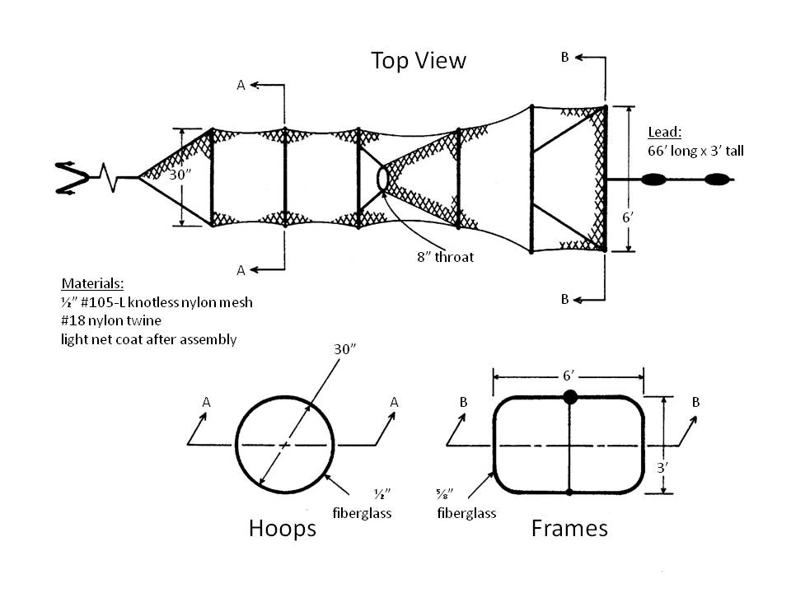

*Graphic adapted from Schneider, James C. and J. W. Merna. 2000. Fishing gear. Chapter 3 in Schneider, James C. (ed.) 2000. Manual of fisheries survey methods II: with periodic updates. Michigan Department of Natural Resources, Fisheries Special Report 25, Ann Arbor*

1. Timing and Frequency of Collection - once annually per reservoir when surface temps are 60-70 deg Fahrenheit.
2. Sampling Sites
   * 1. Trap nets are to be deployed perpendicular to the shoreline on gradually sloping bottom contours. Nets should be deployed with water depths no greater than 16 feet at the net opening and the entire net (including lead) should be completely submerged at all times. Care should be taken that boat traffic is not impeded by net deployment and that nets are suitably marked with buoys. In reservoirs with actively manipulated water levels, care should be taken that nets remain submerged throughout the deployment.
3. Effort
   * 1. **Random Station Sampling**
        1. Number of overnight net deployments will be determined by the

surface area of the impoundment.

* + - * 1. less than 500 acres = 15 net nights
        2. greater than 500 acres = 30 net nights
        3. Net night requirements may be met by setting all

nets for one night or by setting part of the total

number of nets on consecutive nights.

* + - 1. Effort - total number of decimal hours (e.g. 18.6 hrs) between

net deployment and retrieval

* + - 1. CPUE - (# crappie / effort) x 24 hours and expressed as number

of crappie / net night

* + 1. **Fixed Station Sampling**
       1. Number of overnight net deployments will be restricted only to

the number of nets required to adequately evaluate age and growth from otoliths samples, and therefore will be at the biologist’s discretion (see special instructions).

* + - 1. Effort will not be calculated for this gear code
      2. CPUE will not be calculated for this gear code

1. Site Selection
2. **Random Station Sampling**
   * 1. Using a 300m grid map of the reservoir, identify all shoreline sites (squares touching the reservoir shoreline perimeter or shoreline of interior islands). At biologist’s discretion, exclusion of sites based on inappropriate bottom contour, obstructions, user conflict, etc. may occur.
     2. For large reservoirs (>10,000 acres), total surface area may be subdivided into logical substrata (e.g. upper, middle, lower)
     3. Randomly selected sites which are determined in the field to be inappropriate can be replaced by alternate sites. Alternate sites (within strata, when used) can be chosen *a priori* through randomization or identified in the field, as long as an unbiased field methodology is employed. For example, upon discovering an inappropriate, randomly-selected site, the biologist can flip a coin to determine the direction of travel in search of the next available appropriate site (heads = upstream, tails = downstream). Careful consideration of reservoir contours and unbiased exclusion of sites *a priori* should minimize the need for identifying alternate sites while in the field.
3. **Fixed Station Sampling**
   * 1. Site selection for trap netting crappie spp. for age and growth should be highly biased and at the biologist’s discretion regarding location of net deployments and the amount of effort. Sites should be chosen that maximize catch of all size classes and minimize effort.
     2. Points, creek channels, and brush piles should be targeted as stations for sampling. If stations do not produce good catches, new sampling stations should be selected.
     3. For consistency within a reservoir shoreline sampled for various species, using site numbers from an existing grid (developed as above) is preferred, but not required.
4. Data Collection and Recording
5. Identify stations by Grid No. on Data Form 1. If no Grid No. is available, arbitrary numbers can be assigned. Station numbers must remain the same from year to year to be comparable. Record coordinates (Latitude and Longitude in decimal-degree format) for each net location. Additional descriptive details for net locations should be recorded in field notes. Recording - see Code Instructions, use Data Form 1.
6. Data are recorded immediately after nets are retrieved
7. Record each net's catch separately
8. Individually measure total length (mm) for all crappie and weigh (grams) individuals > 100 mm.
9. Crappie otolith samples - see Special Instructions.
   * 1. no otoliths will be collected for crappie < 120 mm
     2. 20 otoliths will be collected per 1 inch (25 mm) group > 120 mm
     3. 30 otoliths will be collected per 1 inch (25 mm) group > 120 mm if a stunted population is suspected
10. Data Analysis
11. Catch per unit effort, stratified by:
    * 1. Lake
      2. Species
      3. Annual catch data
      4. total effort (net-hours)
      5. total number of individuals per net
      6. mean number of individuals per net for all individuals as well as those individuals <5 inches, >5 inches, >8 inches, and >10 inches
      7. mean, minimum, and maximum values, and standard deviations of individual lengths and weights
      8. PSD and RSD with 95% confidence limits
      9. number of stock-sized, quality-sized, and preferred-sized individuals
12. Length-frequency analysis, stratified by:
13. Lake
    * 1. Species
      2. Annual catch data - tables will be divided into 1 inch (25 mm)

intervals; CPUE, mean relative weights, and 95% confidence intervals will be calculated by size groups

1. Reporting
2. See Regional Report Format

TABLE OF CONTENTS

**Tandem Hoop Net Sampling - Small Impoundments**

GEAR CODE: 33

I. Objective: hoop net sampling is used to collect channel catfish samples for information about the following:

A. Relative abundance/Catch rates

B. Length frequency

C. Age and growth

D. Length-weight relationships

II. Gear Specification

A. General description

1. A tandem set consists of three hoop nets tied together (bridle to cod end)

2. Nets have twine netting with 1 inch bar mesh

3. Net dimensions: largest hoop is 2.5 feet in diameter, net is approximately 11 feet long

4. Nets are tied together with bridles 6 feet in length (allows nets to be fished 3 feet apart).

5. Each net is baited with approximately 2 pounds of cheese log (1/3 of a log) which is placed in a bait container.

B. Materials

1. Netting: #15 twine with 1 inch bar mesh, net-coat treated

2. Hoops: seven fiberglass hoops ½” by ½”, the front hoop is 2.5 feet in diameter with each successive hoop decreasing in diameter.

3. Bait containers: 32 oz plastic sample jars with 25 to 30 holes. Each hole is ¼ inch in diameter.

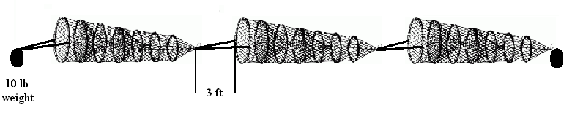

III. Effort

A. Number of net sets will be determined by surface area of the impoundment.

1. less than 50 acres = 3 stations

2. 50-150 acres = 5 stations

3. 150 -250 acres = 8 stations

4. > 250 acres = 10 stations

B. Net night requirements may be met by setting all nets on one day or by setting part of the total number of nets on consecutive days.

C. Effort – 72h set (3 net nights)

D. CPUE - (# channel catfish / effort) and expressed as number / set

IV. Frequency of Collection - once annually per lake from June to August before catfish are stocked that year.

V. Data Collection

A. Sampling sites - Nets are set parallel to the shoreline in 8 to 12 feet of water. Nets may be set shallower if there is insufficient depth or oxygen (<4mg/ml in 8 to 12 feet of water). Select sites along shorelines with no more than a 45o slope to avoid nets from rolling to deeper water. Nets should be set blind to avoid theft (no buoys).

B. Stations - Establish permanent stations on lakes <50 acres. On lakes >50 acres, stations should be randomly selected with 100 yard grids.

C. Recording - see Code Instructions, use Hoop Net Data Form (Data Form 4).

1. Data is recorded immediately after nets are retrieved.

2. Record each net's catch separately.

3. Individually measure total length (mm) for all channel catfish.

4. Weighing of channel catfish is optional.

5. Otoliths should be pulled from 20 fish per inch group.

VI. Data Analysis

A. Catch per unit effort, stratified by:

1. Lake

2. Size groups

a. total number of individuals

b. percent number of individuals

c. CPUE with standard error, CV of the mean, and 95% confidence intervals

d. mean relative weights

e. maximum weights

B. Length-Frequency analysis, stratified by:

1. Lake

2. Annual catch data – tables will be divided into 1-inch (25mm) intervals and the total number of fish in each inch group, the percentage of total for each inch group, and relative weights for each inch group will be given

C. Age and Growth

1. Total number of fish aged

2. Total number of fish of each age

3. Mean length at age (time of sample)

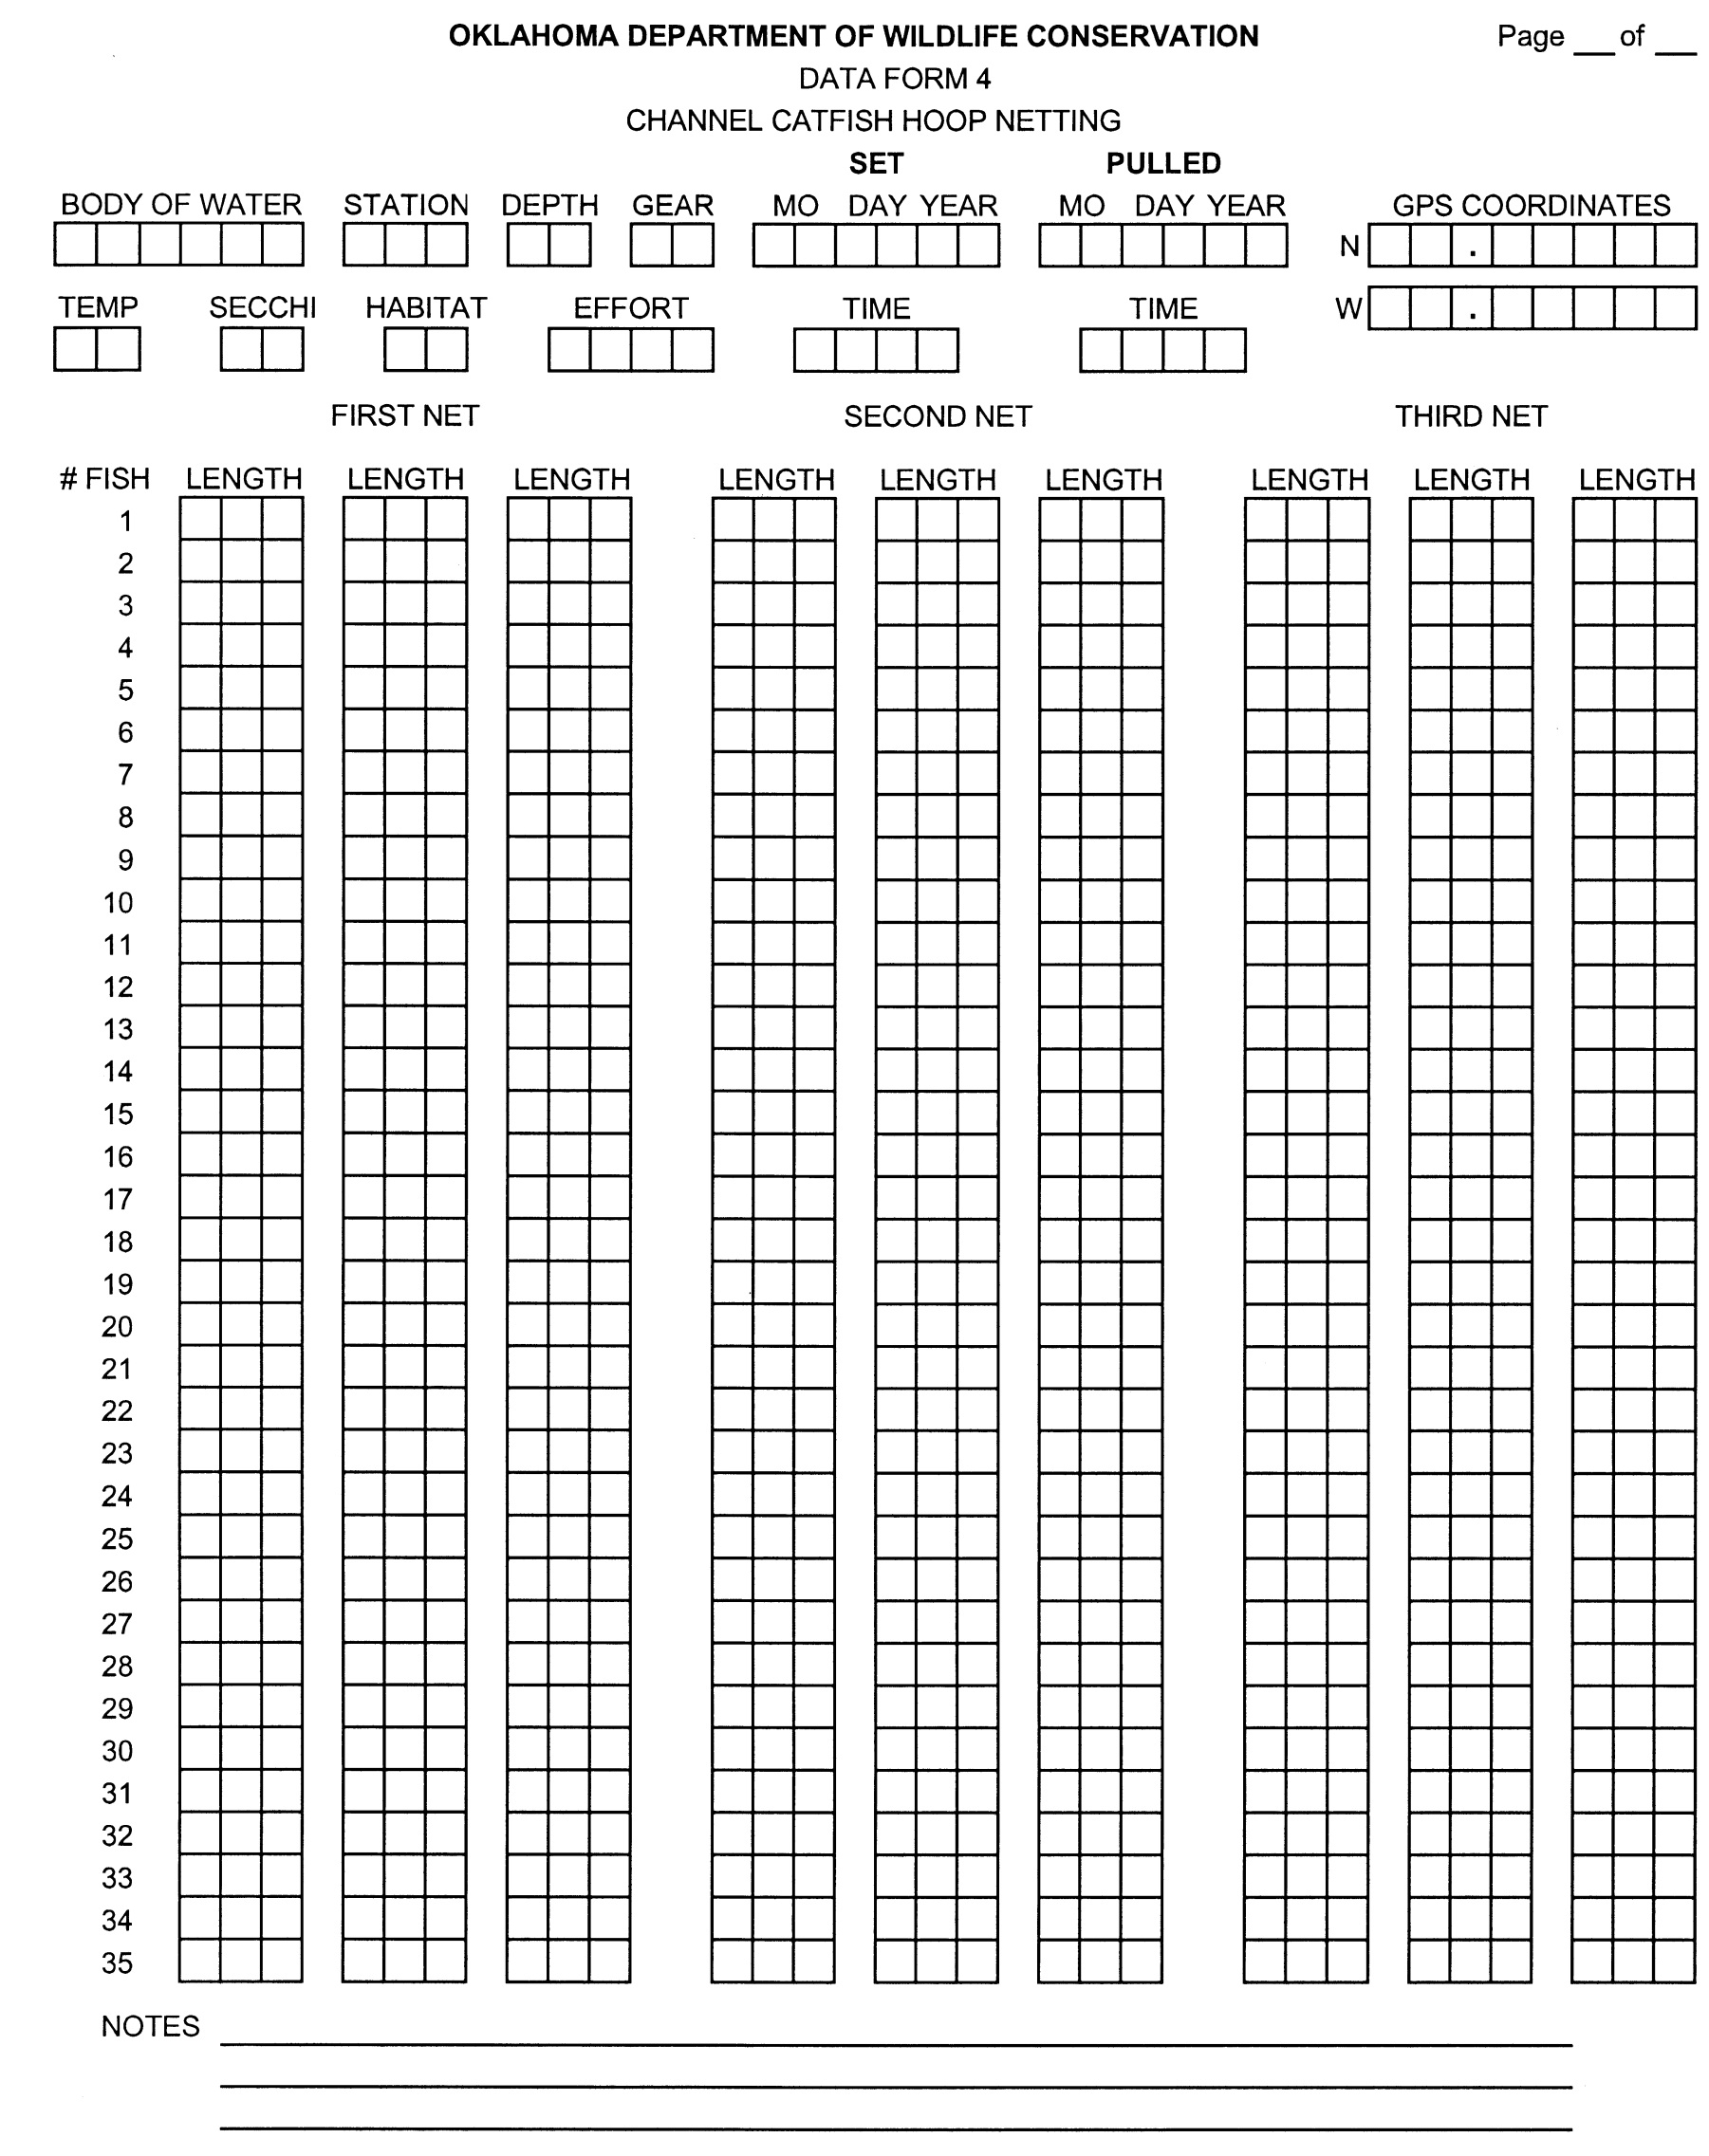

**ELECTROFISHING SAMPLING** (Revised 08/2016)

I.       Objective:  Sampling with electrofishing is used to collect fish samples for information about the following:

A.  Age and growth

B.  Relative weights

C.  Length-frequency

D.  Population structure

E.   Catch rates by species

F.   Year class strength

II.     Standard Gear Specifications (all species)

       A. The header on Data Form 1 should be filled out completely.  Any variables that might affect sampling efficiency should be identified in the field notes (extreme weather, water level fluctuation, turbidity, etc.).

        B. Standardized electrofishing gear includes a Smith-Root GPP 5.0 or 7.5 mounted on an aluminum boat with the hull acting as the cathode.  Two booms with ss dropper cables 4.8-6.4 mm in diameter equally spaced around a 40.6-45.7 cm ring will be used.  Dropper cables will be long enough to submerge 0.6-0.9 meters below the water surface.  The distance between the water line at the bow of the boat and the center of the boom rings is 2.4-2.5 meters, and the distance between the two booms is 1.9-2.0 meters (Chapter 3 in Standard Methods for Sampling North American Freshwater Fishes, Bonar, et al. 2009).

C. Samples should be collected using pulsed DC (60 pulses per second) and, depending on the conditions, optimum amp output used (see Power Output Tables at the end of this section).  A single dipper on the bow of the boat should be used to collect samples.  The dipper will power the electrical field (foot on the pedal) any time the boat is progressing into new (unsampled) water.

III.   Site Selection

A.    **Random Station Sampling**

a. **Random Site Selection** - Sites will be randomly selected using a 300x300yd grid overlay.  Only shoreline sites (grids that touch the shoreline), including island sites if applicable will be selected (no open water sites).  The ArcGIS software used to generate the grid overlay will produce a centroid point of each grid square.  Navigate to the centroid lat/long coordinate, proceed directly to shore, turn to the port side (left) and begin sampling.

B.     **Fixed Station Sampling**

a. **Sampling Stations:** Establish permanent stations in upper, middle and lower lake areas and identify these stations with permanent labels.  The number of stations in each area (upper, middle, lower) is left to the discretion of the Regional Supervisor. If sampling smallmouth bass, stations will be confined to the lower 50% of the reservoir.

b. **Sampling Sites:** Sampling effort (number of units of effort/sites) should be partitioned among the sampling stations at the Regional Supervisor’s discretion.

1. Efforts should be concentrated in known habitat areas. Establishing GPS coordinates for each sampling location is recommended.

a. Identify stations on Data Form 1; arbitrary numbers can be assigned.  Station numbers must remain the same from year to year to be comparable.  More specific locations should be recorded in Field Notes.

b. Select sites within each station in as many habitat types as  possible.

IV.    Effort

A. **Random Station Sampling**

    1. **Unit of effort** - units of effort are measured in 10-minute units of 'actual fishing time.'  Samples must be collected in discrete 10-minute units of effort.  Catch from each 10-minute unit of effort must be recorded separately on an individual data sheet.

                 2. **Catch per unit effort** - number of fish collected per hour.  This is calculated by averaging the number of fish collected in each 10-minute unit of effort and multiplying by 6.

                 3. **Amount of effort** – Minimum number of sites will be determined by surface area of the impoundment.  The target C.V. of mean is 0.20.  If the target C.V. of mean is not obtained using the minimum number of stations additional stations should be sampled not to exceed two times the minimum.

* 1. less than 500 acres =  not more than 6 stations (discretion of the biologist)
  2. 500-1,000 acres = 12 stations (up to 24 stations to reach target C.V. of mean)
  3. 1,000-10,000 acres = 18 stations (up to 36 stations reach target C.V. of mean)
  4. > 10,000 acres = 24 stations (up to 48 stations to reach target C.V. of mean)

4. **Quota** - If C.V. target is met and 150 individuals of target species have not been

obtained, additional sampling should be conducted in known bass habitat to

reach goal for a length frequency.  Extent of additional sampling is left to the

discretion of the Regional Supervisor.

        B. **Fixed Station Sampling**

1. **Quota** - sampling will cease when 150 individuals of the target species have been obtained, or 24 units of effort have been completed.  If the lake being sampled is too small to conduct 24 units of effort without repeating areas already electrofished, sampling can be discontinued once a complete circuit of the shoreline has been completed.

V.   Frequency of Collection

A.  Frequency of collection (years between samples) is left to the discretion of the Regional Supervisor.  Priority should be given to lakes where management methods are being evaluated (such as a change in length limits).

B.  Electrofishing samples (spring or fall) must be collected when surface water temperatures range from 60-75 degrees F.  Care should be taken to not sample when fingerling (0.5-1.5 inch) bass are present to avoid mortality associated with electrofishing.  Sampling during the “pre-spawn” period is preferred.

C.  Sample period - sunrise to sunset except in clear water (mean secchi disk reading >10 feet) impoundments where electrofishing should be conducted sunset to sunrise.  If the target species of the sample is either smallmouth bass or young-of-the-year saugeye, sampling should be conducted after sunset.

VI.  Data Collection

A.    Recording - see Code Instructions, use Data Form 1.

1.      Record each unit of effort separately on Data Form 1.

2.      Completely fill in all data at top of Data Form 1.

3.      Individually measure total length, in millimeters, and weigh all target species.

4.     Otolith samples - See Special Instructions.

VII. Data Analysis

A.    Catch per unit effort, stratified by:

1.      Lake

2.      Species

3.      Size groups

a.      total number of individuals

b.      percent number of individuals

c.      CPUE with standard error, coefficient of variation of the mean, and 95% confidence intervals

d.      mean relative weights

e.      maximum weight

B.    Length-frequency analysis, stratified by:

1.      Lake

2.      Species

                3.      Annual Catch Data - tables will be divided into 1 inch (25 mm) intervals and the number of fish in each inch group, the percentage of total for each inch group, and relative weights by inch group will be given.

        C.     Age and Growth Analysis (Optional)

The basic age and growth analysis will be programmed to include:

1.      Total number of fish aged

2.      Total number of fish of each age

3.      Mean length at age (time of sample)

VIII. Power Output

A.    Introduction - The following power output tables have been adopted from the Florida Fish and Wildlife Conservation Commission Standardized Sampling Manual (Compiled by Kimberly Bonvecchio, 2005).  Electrofishing crews will use these tables to determine the proper amount of power to apply to the fish during standardized sampling.  Surface temperature and conductivity must be measured to compute the correct amount of power.

B.     Calculating Power Output – Measure surface temperature (degrees C) and conductivity (micro Siemens per centimeter) of the water.  Use Table 1 to determine the voltage range required to transfer 3,000 watts of power to the fish.  Transfer that voltage range to Table 2 and match the range with your GPP unit.  Use the correct voltage range setting on the GPP  (for 5.0 GPP 500V = low range and 1000V = high range) to produce the amperage goal from the far right column of Table 2.

*Table 1. Applied voltage levels required to transfer 3000 watts of power to the fish given the conductivity (standardized to 25°C) and temperature of the water.*

|  |  |  |  |  |  |  |  |
| --- | --- | --- | --- | --- | --- | --- | --- |
| **Conductivity**  **(μS/cm)** | **Temperature (°C)** | | | | | | |
| **5** | **10** | **15** | **20** | **25** | **30** | **35** |
| **50** | 5,000-6,000 V | 4,000-5,000 V | 4,000-5,000 V | 4,000-5,000 V | 4,000-5,000 V | 3,000-4,000 V | 3,000-4,000 V |
| **100** | 3,000-4,000 V | 3,000-4,000 V | 3,000-4,000 V | 3,000-4,000 V | 3,000-4,000 V | 3,000-4,000 V | 3,000-4,000 V |
| **200** | 3,000-4,000 V | 3,000-4,000 V | 3,000-4,000 V | 3,000-4,000 V | 3,000-4,000 V | 3,000-4,000 V | 3,000-4,000 V |
| **300** | 3,000-4,000 V | 3,000-4,000 V | 3,000-4,000 V | 3,000-4,000 V | 3,000-4,000 V | 3,000-4,000 V | 3,000-4,000 V |
| **400** | 3,000-4,000 V | 3,000-4,000 V | 3,000-4,000 V | 3,000-4,000 V | 3,000-4,000 V | 3,000-4,000 V | 4,000-5,000 V |
| **500** | 3,000-4,000 V | 3,000-4,000 V | 3,000-4,000 V | 4,000-5,000 V | 4,000-5,000 V | 4,000-5,000 V | 4,000-5,000 V |
| **600** | 3,000-4,000 V | 3,000-4,000 V | 4,000-5,000 V | 4,000-5,000 V | 4,000-5,000 V | 4,000-5,000 V | 5,000-6,000 V |
| **700** | 3,000-4,000 V | 4,000-5,000 V | 4,000-5,000 V | 4,000-5,000 V | 5,000-6,000 V | 5,000-6,000 V | 5,000-6,000 V |
| **800** | 4,000-5,000 V | 4,000-5,000 V | 4,000-5,000 V | 5,000-6,000 V | 5,000-6,000 V | 6,000-7,000 V | 6,000-7,000 V |
| **900** | 4,000-5,000 V | 4,000-5,000 V | 5,000-6,000 V | 5,000-6,000 V | 6,000-7,000 V | 6,000-7,000 V | 6,000-7,000 V |
| **1000** | 4,000-5,000 V | 5,000-6,000 V | 5,000-6,000 V | 6,000-7,000 V | 6,000-7,000 V | 7,000-8,000 V | 7,000-8,000 V |
| **1100** | 5,000-6,000 V | 5,000-6,000 V | 6,000-7,000 V | 6,000-7,000 V | 7,000-8,000 V | 7,000-8,000 V | 8,000-9,000 V |
| **1200** | 5,000-6,000 V | 5,000-6,000 V | 6,000-7,000 V | 7,000-8,000 V | 7,000-8,000 V | 8,000-9,000 V | 8,000-9,000 V |
| **1300** | 5,000-6,000 V | 6,000-7,000 V | 6,000-7,000 V | 7,000-8,000 V | 8,000-9,000 V | 8,000-9,000 V |  |
| **1400** | 5,000-6,000 V | 6,000-7,000 V | 7,000-8,000 V | 7,000-8,000 V | 8,000-9,000 V |  |  |
| **1500** | 6,000-7,000 V | 6,000-7,000 V | 7,000-8,000 V | 8,000-9,000 V |  |  |  |
| **1600** | 6,000-7,000 V | 7,000-8,000 V | 8,000-9,000 V | 8,000-9,000 V |  |  |  |
| **1700** | 6,000-7,000 V | 7,000-8,000 V | 8,000-9,000 V |  |  |  |  |
| **1800** | 7,000-8,000 V | 8,000-9,000 V | 8,000-9,000 V |  |  |  |  |
| **1900** | 7,000-8,000 V | 8,000-9,000 V |  |  |  |  |  |
| **2000** | 7,000-8,000 V | 8,000-9,000 V |  |  |  |  |  |

*Table 2. Amperage goal for a given electrofisher, voltage range set at 50% of range, and voltage level from Table 1. If a particular grouping is not listed for a particular electrofisher, then that electrofisher should not be used given the conductivity and temperature of the water.*

|  |  |  |  |
| --- | --- | --- | --- |
| **Electrofisher** | **Voltage Range Setting** | **Voltage Level from Table 1** | **Amperage Goal** |
| **5.0 GPP** | **500 V** | **3,000-4,000** | **6-8** |
| **4,000-5,000** | **8-10** |
| **1000V** | **3,000-4,000** | **3-4** |
| **4,000-5,000** | **5-6** |
| **7.5 GPP** | **340V** | **3,000-4,000** | **9-11** |
| **4,000-5,000** | **11+** |
| **5,000-8,000** | **>12** |
| **500V** | **3,000-4,000** | **6-8** |
| **4,000-5,000** | **8-10** |
| **5,000-6,000** | **8-10** |
| **6,000-7,000** | **11+** |
| **7,000-8,000** | **>12** |
| **1000V** | **3,000-4,000** | **3-4** |
| **4,000-5,000** | **4-5** |
| **5,000-6,000** | **5-6** |
| **6,000-7,000** | **6-7** |
| **7,000-8,000** | **7-8** |
| **9.0 GPP** | **340 V** | **3,000-4,000** | **9-11** |
| **4,000-5,000** | **11+** |
| **5,000-9,000** | **>12** |
| **680 V** | **3,000-4,000** | **4-6** |
| **4,000-5,000** | **6-7** |
| **5,000-6,000** | **7-9** |
| **6,000-7,000** | **8-10** |
| **7,000-8,000** | **10-12** |
| **8,000-9,000** | **12+** |

**FLATHEAD AND BLUE CATFISH ELECTROFISHING** (Revised 7/23/09)

GEAR CODE: 98

I. Objective: Sampling with electrofishing is used to collect catfish samples for information about the following:

A. Length frequency

B. Relative weight

C. CPUE by size class

D. Year-class strength

E. Age and growth

II. Gear Specifications

A. An aluminum electrofishing boat using a Smith-Root GPP 5.0 or 7.5 with the hull acting as the cathode is required for this effort. The shocker boat will be set up in standard electrode configuration using two booms with ss dropper cables arranged in a Wisconson ring. Use low pulse rates (15 pps) with the appropriate output (Approx 4 amps).

B. **Two** additional chase boats are also **required** to pick up stunned individuals.

C. One dipper will be used on each of the three boats.

III. Effort

A. **Unit of effort** - units of effort are measured in 5-minute units of 'actual fishing time.' Samples must be collected in discrete 5-minute units of effort. Catch from each 5-minute unit of effort must be recorded separately on an individual data sheet.

**Catch per unit effort** - number of fish collected per hour. This is calculated by averaging the number of fish collected in each 5-minute unit of effort and multiplying by 12.

B. **Amount of effort**

1. At each site, 5 minutes (one unit of effort) will be required.

2. Amount of sampling required:

Large Lakes (>10,000ac) = **18 sites** (90 minutes total) for each lake.

S Lakes (<10,000ac) = **9 sites** (45 minutes total) for each lake.

Special Small Lakes (<1,000ac) = Biologist discretion.

IV. Frequency of Collection

A. Once annually per lake when the surface water temperature~~s~~ ranges from 65 to 85°F.

B. Sample period - sunrise to sunset.

C. Flathead Catfish - sampling during the pre-spawning period for flathead catfish is preferred (late-May) but may be extended through July.

D. Blue Catfish – May through October, as long as water temperature requirements are met.

V. Data Collection

BLUE CATFISH

A. Sampling sites

1. Sampling should concentrate in the upper portion of the reservoir. Upper reservoir is defined as the upper most distance from the dam (50% of reservoir length). Sample in depths ranging from 10-40ft.

2. Sites will be selected in a random or stratified-random design from a grid overlay of each lake. Grids will be comprised of numbered 300 meter x 300 meter squares (approx. 18 acres).

a. Identify Grid Number on Data Form 1. More specific location should be recorded in Field Notes.

B. Electrofishing procedure

1. During the 5- minute unit of effort, the electrofishing boat will remain stationary until fish begin to surface (60-90 seconds after the shocking petal is depressed). As the density of surfaced fish changes, the electrofishing boat should move slowly to follow the moving school of blue catfish. The chase boats pick up fish out of reach of the shocker boat personnel.

2. Only blue catfish will be picked up during this procedure.

C. Recording

1. Biological data will be recorded on regular SSP Data Form 1. Include all information at the top of Data Form including time, surface temperature, secchi disc, conductivity, gear length, and effort.

2. Separate data sheets should be recorded at each site.

3. Record total length in mm, weight in grams or ounces and, if possible, sex for each individual catfish. If no individuals were collected, a "98" should be recorded for species code, and a “0” for number of individuals. Weight recorded in ounces in the field should be converted to grams prior to data entry.

FLATHEAD CATFISH

1. Sampling Sites
   1. Efforts should be concentrated in areas of known or suspected flathead concentrations.

2. Flathead Catfish - Site selection for flathead catfish should include rocky points, rip-rap, log piles, undercut banks, and timbered creek channels. Bank inclines should be moderate to steep

B. Electrofishing procedure

1. Sampling all habitat types:

The electrofishing boat will remain stationary until fish begin to surface (60-90 seconds after the shocking petal is depressed). As the density of surfacing fish changes, the shocking boat will be driven slowly along the shoreline during the remainder of the 5 minute effort. The chase boats will pick up fish out of reach of the shocker boat personnel.

2. Only flathead catfish will be picked up during this procedure.

C. Recording

1. Biological data will be recorded on regular SSP Data Form 1. Include all information at the top of Data Form including time, surface temperature, secchi disc, conductivity, gear length, and effort.

2. Separate data sheets should be recorded at each site.

3. Record total length in mm, weight in grams or ounces and, if possible, sex for each individual catfish. If no individuals were collected, a "98" should be recorded. Weight recorded in ounces in the field should be converted to grams prior to data entry.

VI. Data Analysis

A. Catch per unit effort, stratified by:

1. Lake

2. Species

3. Size groups

a. total number of individuals

b. percent number of individuals

c. CPUE with standard error, coefficient of variation of the mean, and 95% confidence intervals

d. mean relative weights

e. maximum weight

B. Length-frequency analysis, stratified by:

1. Lake

2. Species

3. Annual Catch Data - tables will be divided into 1 inch (25 mm) intervals and the number of fish in each inch group, the percentage of total for each inch group, and relative weights by inch group will be given.

C. Age and Growth Analysis (Optional)

The basic age and growth analysis will be programmed to include:

1. Total number of fish aged

2. Total number of fish of each age

3. Mean length at age (time of sample)

TABLE OF CONTENTS

**STREAM ELECTROFISHING SAMPLING** (Revised 4/07)

I. Objective **-** Sampling with electrofishing is used to collect fish samples for information about the following:

A. Relative weights

B. Length-frequency

C. Population age and size structure

D. Year-class strength

E. Abundance

II. Standard Gear Specifications (all species):

1. Standardization electrofishing gear includes a Smith-Root GPP 2.5 mounted on an aluminum boat with the hull acting as the cathode. A single boom with stainless steel dropper cables arranged in an umbrella array will be used as the anode.
2. Samples should be collected using pulsed DC and, depending on the conditions, adjustments should be made so that optimum amperage output is used.
3. An outboard motor should be used to maneuver the boat when feasible. Otherwise, the boat will be maneuvered by an individual wearing chest waders, rubber linesman’s gloves and other protective clothing as needed.
4. A single dipper on the bow of the boat should be used to collect samples. The boat driver should not dip fish.

III. Effort:

1. **Unit of effort** - units of effort are measured in discrete 5-minute units of ‘actual fishing time.’ Samples must be collected in 5-minute units of effort. Catch from each 5-minute unit of effort must be recorded separately on Data Form 1.
2. **Catch per unit effort** - number of fish collected per hour. This is calculated by averaging the number of fish collected in each 5-minute unit of effort and multiplying by 12.
3. **Amount of effort** - a quota system will determine the amount of effort required in sampling.
4. **Quota** - Sampling at each station will consist of as many 5-minute units of effort (sites; see below) needed to adequately sample all mesohabitat types available at the station. It is not necessary to equally proportion units of effort among the four stations sampled per stream. Fish collected in each unit of effort need to be removed from the sampling area (i.e., above or below a natural barrier) to avoid re-sampling individual fish. An alternative to this approach is to mark collected fish with a caudal fin clip such that they can be easily identified and not included in subsequent units of effort.

IV. Frequency of Collection:

A. Frequency of collection (years between samples) is at the discretion of the Streams Program Coordinator.

B. Samples must be collected in spring to early summer when flows are suitable for sampling.

C. Sample period is between sunrise and sunset (daytime). Sampling should be conducted between sunset and sunrise (dark) if the target species of the sample is trout.

V. Data Collection:

A. **Sampling stations -** Potential sampling stations will be chosen, based on stream morphology (e.g. depth) and accessibility, from a representative reach along each selected stream. Both accessible and remote areas will be used to minimize bias associated with stream access. As many potential sampling stations as feasible should be established on each stream. Legal descriptions, vernacular references and location coordinates (latitude and longitude) of proposed sites will be recorded. A minimum of four sampling stations should be randomly selected at each stream from the pool of potential stations using probability routines.

B. **Sampling sites -** Sites represent each unit of effort. Sampling effort [number of units of effort (sites)] is based on the quota system described above.

C. **Target species -** All black bass species (largemouth, spotted, and smallmouth) must be collected in the sample. Sunfish (all *Lepomis spp.*, rock bass and warmouth) must also be included in the sample. Other species are to be collected at the discretion of the biologist or Streams Program Coordinator.

D. **Recording** - See Code Instructions; use Data Form 1.

1. The header on Data Form 1 should be filled out completely. Any variables that might affect sampling efficiency should be identified in the field notes.

2. Record each unit of effort (site) separately on Data Form 1 printed on water proof paper.

3. Individually measure total length (millimeters) of all target species. Weigh (grams) all target species greater than 100 mm.

4. Otolith samples - See Special Instructions. These structures should be collected at the discretion of the biologist or Streams Program Coordinator.

VI. Data Analysis:

A. Catch per unit effort, stratified by:

1. Stream

2. Species

3. Total number of individuals

4. Size groups:

a. CPUE with standard error, coefficient of variation of the mean, and 95% confidence intervals

c. mean relative weights

d. maximum weight

B. Length-frequency analysis, stratified by:

1. Stream

2. Species

3. Total Catch - tables will be divided into 1 inch (25 mm) length intervals. The number in each inch group, the percentage of total for each inch group and relative weights by inch group will be displayed.

C. Age and Growth Analysis (Optional):

The basic age and growth analysis will be programmed to include:

1. Total number of fish aged

2. Total number of fish at each age

3. Mean length at age at the time of sample

TABLE OF CONTENTS

**SNORKEL AND SCUBA DIVING SAMPLING** - (Optional)

1. Objective: Surveys using snorkeling or SCUBA gear may be conducted in streams where conventional electrofishing and seining gear are ineffective due to stream morphology, conductivity levels or limited access to determine:
   1. Density of target species
   2. Distribution of target species
2. Standard Gear (required):
   1. Snorkeling gear:
3. Diving mask with purge valve
4. Snorkel with purge valve
5. Swim fins
6. Exposure suit (wet, semi-dry or dry) appropriate for anticipated water temperatures or hazards
   1. Scuba gear:
7. Diving mask with purge valve
8. Snorkel with purge valve
9. Swim fins
10. Exposure suit (wet, semi-dry or dry), gloves and hood as needed for anticipated water temperatures or hazards
11. Buoyancy compensator (BC)
12. First stage regulator (on tank)
13. Second stage regulator (primary air source; regulator)
14. Alternate air source (regulator)
15. Certified air cylinder
16. Air pressure gage
17. Depth gage
18. Compass
19. Dive knife
20. Appropriate weight (on belt or BC) to attain neutral buoyancy
21. Snorkeling and SCUBA Diving Safety Guidelines:
    1. All personnel conducting surveys using SCUBA gear must be certified from a recognized diving organization as an Open Water Diver.
    2. No observer will ever dive alone.
    3. Divers should be trained in CPR and fist aide.
    4. A dive plan must be completed prior to any dive and all divers must approve the plan.
    5. Each diver should inspect his and his partners diving gear before any dive. This includes checking for the proper function of buoyancy compensators, gages, regulators, all air system connections, releases on weight belts and the presence of other required equipment.
    6. All divers and their partners must be able to effectively communicate using underwater hand signals.
    7. All divers should know the location of the nearest decompression chamber.
    8. Divers must have a cellular phone nearby, in a location known to the entire team, equipped with the number to the Divers Alert Network.
    9. No diver should enter the water if he is not comfortable with the diving conditions or plan.
    10. Divers should never dive in streams that have: 1) flow conditions that are not conducive to safe maneuvering; or 2) unusual or extreme hazards (e.g., dangerous strainers, vortex rollers, etc.)
22. Data Collection Methods - data collection methods for snorkeling and SCUBA surveys will be identical but water depth and clarity will dictate which method should be used.
    1. Snorkeling and SCUBA surveys may be conducted anytime of year to determine the abundance and distribution of target species.
    2. Surveys should be conducted during daylight hours only.
    3. Field crews should determine the total sampling area of each stream being surveyed. This will be calculated by measuring the length of each survey reach and multiplying this by the average width of each survey reach. Average stream width will be determined by measuring the wetted width at a minimum of three representative cross sections and obtaining a mean from these results. The total sampling area will then be calculated by summing the areas of each reach being surveyed. This total sampling area will then be converted to acres.
    4. Prior to the start of each survey, staff should determine the maximum underwater distance (maximum visibility measurement) in which they can positively identify the species in question. This will be determined by underwater observation of a life-sized picture of the target species at varied distances.
    5. Maximum visibility measurements and the mean stream width measurements will determine how far apart the divers will be in the water (lane width) and how many transects will be needed to cover the entire sampling area.
    6. Transects will begin at the down stream end of each stream reach being evaluated. Divers will swim upstream in predetermined lanes counting all fish that can be positively identified within their lanes. Divers will maintain proper spacing during transects by marking the determined lane width on a piece of PVC pipe and holding the pipe as they move through the water.
    7. Fish observations will be recorded on an underwater tablet and this information will be transferred to Data Form 1 at the end of each transect.
    8. A minimum of three complete surveys, potentially including multiple transects per survey, must be completed in each stream to determine abundance estimates.
    9. If the stream is small, and divers can easily count all of the fish in question with one transect, the sample reach should be divided in half (longitudinally). Divers should then swim together along the channel center and count all fish between the center and their respective bank. In this case, one transect will compose a survey and a minimum of three surveys will be conducted to complete the stream evaluation.
23. Data Analysis:
    1. Density estimates:
24. If the stream is small, and all fish can be counted with two divers during one transect, density will be estimated using data from the three surveys. The formula *N = 2Nm - Nm-1* will then be applied, where “*N*” is the total estimate, “*Nm*” is the largest sample count, and “*Nm-1*” is the second largest sample count. This estimate will be divided by the sampling area to obtain the density estimate, per acre, for the reach surveyed (*D = N/acres*).

*Example:*

Three surveys are completed in a narrow stream with a total sampling area of two-acres.

Two-Acres of Stream Sampled

Survey Large Fish Medium Fish Small Fish Total Fish

1 6 12 8 26

2 3 24 16 43

3 4 11 9 24

*N = 2(43) – 26* where *Nm =43* (largest sample) and *Nm-1 = 26* (second largest sample).

*N = 60* and density *(D) = 60/2-acres =* **30 fish per acre**

1. If multiple transects are needed to evaluate a stream (wide streams), density will be estimated by calculating a mean and standard error from all transects. The formula *N = (N mean)(EF)* will be used, where “*N mean*” is the mean of all fish sighted and “*EF*” is the expansion factor. The result is divided by the total sampling area to determine an overall density estimate (*D = N/acres*). The expansion factor (*EF*) applied to the density is calculated *EF = (mean stream width) / (counting lanes) / (visual distance),* and this is also applied to the standard error estimates (*SE*). Confidence limits can then be applied to these estimates using a 95% confidence interval with the formula *D +/- t(SE),* where “*t*” is derived from a t-table and the degrees of freedom (df) for the “*t*” value is one less than the number of sample passes performed (e.g., three 3 sample passes made, df = 2, *t* = 4.30).

*Example:*

Three surveys are completed in a wide stream with a total in a sample area of two-acres. The mean stream width is 45-meters requiring four counting lanes. Each counting lane has a four-meter wide visual corridor.

Two-Acres of Stream Sampled

Survey Lane 1 Lane 2 Lane 3 Lane 4 Total

1 13 13 8 13 47

2 11 5 11 15 42

3 20 9 5 10 44

Mean 15 9 8 13 44

SE 2.73 2.31 1.73 1.45 1.45

*EF* = Mean stream width = 45 meters; 4 counting lanes; 4 meter wide visual corridor.

*EF = 45 / 4 / 4*

*EF = 2.81*

*N = (N mean)(EF*) where“*N mean*”is the mean of all fish sighted.

*N = (44)(2.81)*

*N = 124* and density *(D) = 124/2-acres =* **62 fish per acre**

Standard error will also be expanded:

*1.45(2.81) = 4.07*

Adjust for area:

*4.07/ 2-acres = 2.04*

*62 +/- 4.30(2.04) =* **62 +/- 9 fish per acre**

* 1. Distribution - When snorkeling or scuba diving surveys are completed to determine the distribution of certain species, GPS coordinates will be recorded at sites where these species are located and these sites will be identified on an aerial photograph.

TABLE OF CONTENTS

**STREAM HABITAT SAMPLING** (Revised 4/07)

1. When deemed necessary by the Streams Program Coordinator, study reaches will be classified using the Rosgen stream classification system*. This will facilitate communication about stream fish data among professionals in a variety of disciplines. The ability to predict stream behavior, determine departure from reference conditions and make defensible recommendations or applied management plans will also be enhanced using this procedure.
2. Information for a level two (morphological) stream assessment will be collected from a representative segment of each stream reach that is two meander wavelengths (about 20-30 mean channel widths) or two riffle-pool sequences (higher order streams) in length. This information will include:
   1. A longitudinal profile plot and determination of reach length measured using standard survey procedures.
   2. Thalweg, bankfull, and water surface elevations measured at stations located along the longitudinal profile at the beginning, middle and end of each distinct channel unit (i.e., riffle, pool, run).
   3. Cross-sections will be surveyed at one representative riffle and pool (2 cross-sections total) within the segment to determine bankfull width and elevations of bankfull depth, waters surface and thalweg.
   4. Stream meander geometry and valley metrics will be measured for the reach and recorded on site map (plan view). Measurements should include sinuosity and meander wavelength, amplitude, belt width and radius of curvature and these may be determined from aerial photos or field surveys.
   5. Bed materials will be evaluated from proportionally allocated pool and riffle cross-sections using the first touch modified Wolman* pebble count procedure.
   6. All the above data will be used to characterize channel profile, dimensions, pattern, and bed materials in the reference condition and to classify the channel into a discrete stream type.
   7. The following literature and documents will be used to determine standard survey procedures:

1. Basic Assessment and Restoration of Degraded Streams (Internal Streams Management Program workbook)

2. Stream Restoration; A Natural Channel Design Approach (Prepared by the North Carolina Stream Restoration Institute and North Carolina Sea Grant)

3. Stream Channel Reference Sites: an Illustrated Guide to Field Techniques (Cheryl C. Harrelson, C.L. Rawlins and John P. Potyondy)

*Rosgen, D. 1996. Applied river morphology. Printed Media Companies, Minneapolis, Minnesota.

TABLE OF CONTENTS

**WATER QUALITY SAMPLING** (Optional)

I. Objective: To monitor on a periodic or annual basis, the most critical water quality conditions existing within the impoundment.

II. Gear Specification

A. Secchi disc

B. Temperature - Yellow Springs Instrument Model 57 or equal

C. D.O. - Yellow Springs Instrument Model 57 or equal

D. ph - Hach DR-EL (optional)

E. Conductivity - Yellow Springs Instrument S-C-T, Hach DR-EL, or equal

III. Effort

A. Less than 100 acres = 1 permanent station, deepest part of the reservoir.

B. Greater than 100 acres = 2 permanent stations; one at lower end near dam and one in upper end, opposite dam.

C. The need for more stations or more samples is left to the discretion of the biologist.

IV. Frequency of Collections

Profiles will be recorded in August or September each year.

V. Data Collection

A. Sampling period:

Field determinations will be made between 9:00 a.m. and 5:00 p.m., C.S.T. All measurements will be recorded on Data Form 2.

B. Temperature:

Temperature profiles as degrees Centigrade (nearest tenth) are recorded at one meter intervals from surface to bottom. Note: Be sure to include bottom sample as separate reading. (See Data Form 2)

C. Dissolved Oxygen (D.O.)

Record as milligrams per liter to the nearest tenth at one meter intervals from surface to bottom. (Bottom is separate reading.)

D. Conductivity (micromhos/cm at 25°C) record values at surface and one meter from bottom.

E. pH is measured to nearest tenth at surface, mid-depth, and one meter from bottom.

F. Secchi disc reading - record values in inches.

G. Optional - other water quality data may be taken for laboratory analysis at the State Water Quality Laboratory. The Water Quality Lab will analyze our samples for alkalinity, pH, chlorides, conductivity, turbidity, nitrogen, phosphorus, and C.O.D. They require that the sample be taken and labeled properly and delivered immediately upon collection (within 8-10 hours). Samples can be shipped by bus or delivered in person.

VI. Data Analysis – Temperature data will be converted from Celsius to Fahrenheit; D.O. data will be converted from mg/L to ppm; and depth will be converted from meters to feet. Water quality data will be graphically represented in oxygen and temperature profiles.

VII. Reporting

See Annual Report format.

TABLE OF CONTENTS

**Creel Survey (optional)**

**I. Objective:** Creel surveys can be used when evaluating angler use, angler catch, angler harvest, angler opinion, angler satisfaction and angler economics

**II. Survey types**

1. Roving surveys
2. Roving surveys are generally done from a boat but can be done on foot/vehicle on streams and small lakes (<100 acres).
3. Access point (bus route) surveys
4. Access point surveys
   1. To be used only when boat or foot/vehicle access is limited
      * + 1. **Roving survey scheduling**

A. Daylight only

B. Minimum 20 survey days per quarter (season/3-month)

a. 12 weekend days/quarter randomly selected

b. 8 weekdays/quarter randomly selected

C. Winter quarter (Nov-Feb) on most reservoirs is optional since less than 10% of the total fishing pressure usually occurs in that season.

1. Creel period start each sampling day
   * 1. 8 hour creel day= sunrise up to 8 hours before sunset randomly selected
     2. 6 hour creel day=sunrise up to 6 hours before sunset randomly selected
     3. Etc.
2. Should be at least four creel period per creel day (Preferably where interviews and pressure counts are both taken
   * 1. Creel periods in each day can be scheduled as equal block of time or random blocks of time
3. At least two pressure counts per creel day
   * 1. Pressure counts on an area or entire body of water must be done within one hour.
     2. Pressure counts can be done at the start or end of each creel period.
     3. The more pressure counts scheduled, the better
4. Count/interview direction
   1. Direction should be clockwise or counter clockwise, selected randomly
5. No creel activities, either interviews or pressure should be done after the time of official sunset
   * + - 1. **Access point survey scheduling**
6. Same as roving survey above for A., B., and C., except that either daytime or night-time or both survey times can be used.
7. If at all possible try and schedule the survey day where all access point are surveyed each survey day, e.g., six access points equals six creel periods.
8. If necessary schedule the order of access points in their logistic order (bus route). Otherwise schedule each creel period (access point) randomly.
9. The first creel period (access point) in a survey day should be randomly selected.
10. Car counts at each access point are substituted for pressure counts. Cars are counted at the beginning of the creel period and then cars leaving and arriving are also counted during the entire creel period.
11. Because of the necessity of counting cars leaving and arriving, interviews must be done within seeing distance of the parking lot.
12. Most interviews will be completed trips. Do not interview anyone who has not been fishing for at least 15 minutes.
13. Make sure to leave an individual creel period (access point) in time to make the scheduled time at for the next creel period (access point)

**V. Creel survey pressure count data recording**

1. Date, section, time of count, day type (DD or DE)
2. Record numbers of boats, boat anglers, bank anglers, tube anglers and dock anglers (roving survey).
   1. For access surveys, record number of cars when arriving at the access point (creel period) and record numbers of cars leaving and arriving during the creel period.

**VI. Creel survey interviews**

1. Date, section, day type (WE or WD), type of fishing (boat, bank, tube or dock)
2. Number in party
3. Time started fishing
4. Time interviewed or time fishing stopped, whichever came first
5. Finished?
6. Species sought (only one, see species codes for other gear). Could be “anything”.
7. Species, number and weight of individual fish caught and kept
8. Species and number of fish released
9. Any other pertinent information as needed, such as:
   1. no. of adults and children in party
   2. year of birth
   3. home zip code
   4. trip rank
   5. demographic questions
   6. preference questions
   7. satisfaction questions
   8. economic question
10. Remarks
11. Interviewer’s initials

**VII. Analysis**

1. Standard creel analysis techniques with the follow amendments:
2. Stratify pressure, catch and harvest analysis by quarter, section and day type
3. Expand pressure counts by total daylight hours available in strata
4. Calculate catch and harvest rate as a ratio-of-totals not mean-of-ratios method so as not to give equal weight to all unsuccessful anglers, regardless of time spent fishing (see Earls, G.A. 1973. *Comparison of man-days of fishing and fish harvest above and below a flood control hydroelectric impoundment bisecting an Oklahoma scenic river.* Master’s Thesis, Oklahoma State University. 123 pp.)
5. Calculate total hours of fishing for each party (each interview) by multiplying the interview interval by number in party.
6. For each strata calculate:
   1. Total hours of fishing by boat, bank, tube and dock anglers for each

strata

* 1. Catch rate, harvest rate and harvest for each strata

1. Calculate total number of trips by dividing total hours of fishing by mean hours of FINISHED fishing interviews for any strata
2. Access point fishing pressure is calculated by
   1. determining the average party size from interviews
   2. mean number of cars per hour in each access point
   3. a * b = mean number of angler per hour
   4. c * total hours of daylight hours per strata= total angler hours in that access point per strata

**CODE INSTRUCTIONS**

DATA SHEETS

Field data forms should be sent to the Oklahoma Fishery Research Laboratory following completion of each sampling segment (spring sampling is considered one segment, while summer, fall, and winter sampling are considered a second segment). Data for each sampling segment and reservoir should be sent together. Raw data sheets should be proofread, rewritten (if necessary), and copied before being sent to the OFRL.

Information at the top of the field data form must appear on every sheet that follows. Do not put additional information that is not asked for around the data on the field data sheet. There is a place under "Field Notes" for this kind of information. Under the length or weight categories, do not put "adult" or "YOY" - the computer does not understand these terms.

1. BODY OF WATER

Lakes and reservoirs will be recorded as designated in the Reservoir Code. If no code has been assigned, call the Research Laboratory for the proper coding. Reservoir and river codes are listed below.

Adair Recreational Area ADAIR

Altus City ALTCIT

Altus-Lugert LUGERT

American Horse AMHORS

Arbuckle ARBUCK

Arcadia ARCADI

Ardmore City ARDCIT

Atoka Lake ATOKA

Atoka Bluestem ATOBLU

Bartlesville BARTLE

Beaver BEAVER

Beggs BEGGS

Bell Cow BELLCO

Birch BIRCH

Bixhoma BIXHOM

Bluestem BLUEST

Boomer BOOMER

Boren BOREN

Boswell BOSWEL

Boyer BOYER

Bristow BRISTO

Broken Bow BRBOW

Burtschi BURTSC

Cache Creek CACHEC

Caddo 18 CADD18

Canton CANTON

Carl Blackwell BLACK

Carl Albert CARLAL

Carlton CARLTO

Carter CARTER

Cedar CEDAR

Chambers CHAMBE

Chandler CHANDL

Chelsea City CHELSE

Chi Chickasha CHICKA

Chimney Rock CHROCK

Chleshoma CHELSH

Chouteau L&D 17 CHOUTE

Church CHURCH

Claremore City CLAREM

Clayton CLAYTO

Clear Creek CLEARA

Clearview CLEARV

Cleveland CLEVEL

Clinton CLINTO

Coalgate COALGA

Comanche COMANC

Coon Creek COONCK

Copan COPAN

Crowder CROWDE

Cushing CUSHIN

Dahlgren DALGRN

Dead Indian DEADIN

Dripping Springs DRSPGS

Duncan DUNCAN

Dustin DUSTIN

El Reno ELRENO

Elk City ELKCIT

Ellsworth ELLSWO

Elmer ELMER

Elmer Thomas ELMERT

Etling ETLING

Eucha EUCHA

Eufaula EUFAUL

Central Arm CENTRL

Deep Fork Arm DEEPFK

Gaines Creek Arm GAINES

North Canadian Arm NORCAN

South Canadian Arm SOUCAN

Evans EVANS

Fairfax FAIRFA

Fort Supply FTSUPP

Fort Cobb FTCOBB

Fort Gibson FTGIB

Flatrock Creek Arm FLATCR

Jackson Bay Arm JACKBA

Taylor Ferry TAYFER

Foss FOSS

Frances FRANCE

Frederick FREDER

Fugate FUGATE

Fuqua FUQUA

George Horany HORANY

Gramma GRAMMA

Grand Lake GRAND

Drowning Creek Arm DROWNC

Elk River Arm ELKRIV

Honey Creek Arm HONEYC

Horse Creek Arm HORSEC

Great Salt Plaint GRSALT

Greenleaf GREENL

Guthrie GUTHRI

Hall HALL

Harthorne HARTSH

Haskell HASKEL

Healdton HEALDT

Hefner HEFNER

Henryetta HENRY

Heyburn HEYBUR

Holdenville HOLDEN

Hominy HOMINY

Hudson HUDSON

Hugo HUGO

Hulah HULAH

Humphreys HUMPHR

Jap Beaver JAPBEA

Jean Neustadt JNEUST

Jed Johnson JEDJOH

Kaw KAW

Keystone KEYSTO

Konawa KONAWA

Langston LANGST

Lawtonka LAWTON

Liberty LIBERT

Lone Chimney LONECH McMurtry MCMURT

Longmire LONGMI

Mannford MANNFO

McGee MCGEE

Meeker MEEKER

Miami Sec. of the Neosho MIAMI

Mountain Fork River MTFORK

Mountain Lake MTLAKE

Muldrow City MULDRO

Murray MURRAY

Nanih Waiya NWAIYA

Neosho River NEOSHO

Newt Graham L&D 18 GRAHAM

Nichols Park NICHOL

Okemah OKEMAH

Okmulgee OKMULG

Onapa ONAPA

Oologah OOLOGA

Optima OPTIMA

Overholser OVERHO

Ozzie Cobb OZCOBB

Pauls Valley PVALLY

Pawhuska PAWHUS

Pawnee PAWNEE

Perry C.C.C. PERRYC

Perry PERRY

Pine Creek PCREEK

Ponca City PONCA

Porum City PORUM

Prague PRAGUE

Pretty Water PRETTY

Purcell PURCEL

Quanah Parker QUANAH

Raymond Gary RAYGAR

Robber's Cave State Park ROBBER

Robert S. Kerr KERR

Rocky ROCKY

Rush RUSH

Sahoma SAHOMA

Sallisaw SALLIS

Sally Jones SJONES

Sardis SARDIS

Schooler SCHOOL

Shawnee Twin #1 SHAWN1

Shawnee Twin #2 SHAWN2

Shell Creek SHELLC

Shidler SHIDLE

Skiatook SKIATO

Skipout SKIPOU

Sooner SOONER

Spavinaw SPAVIN

Spiro SPIRO

Sportsman SPORTS

Spring Creek SPRING

Stanley Draper DRAPER

Stigler STIGLR

Stilwell City Lake STILWE

Stroud STROUD

Sunset SUNSET

Sutton SUTTON

Taft TAFT

Taylor TAYLOR

Temple City TEMPLE

Tenkiller TENKIL

Texoma TEXOMA

Thunderbird THBIRD

Tom Steed STEED

Vanderwork VANDER

Veterans (Sulphur) SULVET

Vian VIAN

Vincent VINCEN

W.D. Mayo WDMAYO

Ward WARD

Watonga WATONG

Waurika WAURIK

Waxhoma WAXHOM

Wayne Wallace WAYWAL

Webbers Falls WFALLS

Weleetka WELEET

Wetumka WETUMK

Wewoka WEWOKA

Wiley Post WIPOST

Wintersmith WINTER

Wister WISTER

Yahola YAHOLA

2. STATION CODE

Station Code will be designated by Grid No. as taken from the publication, Reservoirs of Oklahoma. Arbitrary numbers can be assigned if no Grid No. is available. Station numbers should remain the same each year to be comparable. A more precise description of location should be included in the Field Notes section of the Data Form.

3. DATE CODE

This is the date (month, day, and year) the data is recorded. Completely fill in all boxes.

4. TIME CODE

This is the time the data is recorded based on the 24-hour clock. For example, 10:30 pm would be recorded as 2230. Time is important because the data analysis programs use it to distinguish between day and night electrofishing. The distinction between day and night electrofishing is as follows:

Month Day Night

Mar 0640-1848 1849-0639

Apr 0559-1902 1903-0558

May 0628-2027 2028-0627

Jun 0618-2044 2045-0617

Jul 0629-2041 2042-0628

Aug 0650-2017 2018-0649

Sep 0713-1936 1937-0712

Oct 0738-1855 1856-0737

Nov 0706-1726 1727-0705

5. POOL ELEVATION

This is the elevation of the lake at the time the data is recorded.

Units = feet above mean sea level. If elevations are not available, then arbitrary values can be assigned or leave the Elevation Code area blank.

6. SURFACE TEMP CODE

This is the temperature at the water surface at the time the data is recorded. Units = Degrees Fahrenheit (Recorded to the nearest whole degree.)

7. SECCHI CODE

This is the Secchi Disc reading at the time the data is recorded.

Units = inches (nearest inch).

8. CONDUCTIVITY

This is the conductivity reading at the time the data is recorded.

Units = micromhos/cm at 25° C. Values greater than 9,999 umho/cm should be recorded as 9999 umho/cm in the Conductivity Code boxes. Do not add boxes or write outside of boxes. Record actual value in Field Notes.

9. GEAR

The following codes will be used to designate the gear types being utilized (this code must be included on each data sheet submitted):

|  |  |  |
| --- | --- | --- |
| **Gear Code** | **Gear Name** | **Era** |
| 10 | Shoreline Seine | 1980 - Present |
| 21 | Gill Net - Experimental (Old) | 1980 - 2003 |
| 22 | Gill Net - Other | 1980 - 1992 |
| 23 | Gill Net - Experimental (Current) | 2003 - Present |
| 25.1 | Gill Net - 3/8 - 1-inch Floating | 2003 - 2009 |
| 26 | Gill Net - Paddlefish | ???? - Present |
| 25 | Gill Net - 3/8 - 3/4-inch Floating | 2009 - Present |
| 31 | Trap Net - Crappie | 1992 - Present |
| 31.1 | Trap Net - Standard | 1980 - 1992 |
| 32 | Trap Net - Other | 1980 - 1992 |
| 33 | Hoop Net | 2016 - Present |
| 41 | Electrofishing - All Species | 1992 - Present |
| 41.1 | Electrofishing - Spring (All) | 1980 - 1992 |
| 42.1 | Electrofishing - Bass, Crappie, Sunfish | 1992 - 1999 |
| 42.2 | Electrofishing - Fall (All) | 1980 - 1992 |
| 44.02 | Electrofishing - bass random | 2016 - Present |
| 43.1 | Electrofishing - Bass, Crappie | 1992 - 1999 |
| 43.2 | Electrofishing - Spring (bass, crappie only) | 1980 - 1992 |
| 44.01 | Electrofishing - bass fixed | 2016 - Present |
| 44 | Electrofishing - Bass | 1992 - Present |
| 43.3 | Electrofishing - Fall (Bass, crappie only) | 1980 - 1992 |
| 45 | Electrofishing - Bass, Sunfish | 1992 - Present |
| 46 | Electrofishing - Bass, Perch | 1992 - Present |
| 47 | Electrofishing - Bass, Shad | 1992 - 1999 |
| 48 | Electrofishing - Sunfish | 1992 - Present |
| 49.1 | Electrofishing - Summer (Bass only) | 1980 - 1992 |
| 49 | Electrofishing - Perch | 1992 - Present |
| 98 | Electrofishing - flathead/blue catfish | 2003 - Present |
| 98.1 | Electrofishing - flathead catfish | 1992 - 1999 |

The above species classifications are defined as follows:

Bass - largemouth bass (Florida, northern & hybrids), spotted bass, and smallmouth bass.

Sunfish - all sunfish species.

Perch - sauger, saugeye, and walleye.

10. GEAR LENGTH

Gear length is coded according to gear type being used:

Trap Net = actual length of lead (nearest foot)

Seine = seine length (40 ft or 20 ft)

Electrofish = actual length of electrofishing effort (15 minutes)

Cove Rotenone = actual length of net needed to block cove (nearest foot)

11. HABITAT

Habitat codes vary with the gear type used. If you are shoreline seining, trap netting, or electrofishing, use the following codes to designate substrate and shoreline cover:

Substrate Code

Sand 0

Gravel 1

Rock 2

Clay 3

Mud 4

Unknown 5

Shoreline Cover Code

Vegetated (grass, aquatics) 6

Rock (bedrock, riprap, gravel) 7

Brush (timbered, willows) 8

No Cover 9

Two spaces are provided for habitat designation on the data form. The first space is used to designate substrate (for seining, trap netting, and electrofishing). The second space is used to designate shoreline cover types (for seining, trap netting, and electrofishing).

Example: A shoreline seining station had habitat with sand substrate and no cover. The data would be recorded "0" and "9" in the habitat boxes.

12. EFFORT

This is the unit of effort expended with a given gear type expressed in the following form:

Seine Sampling - effort is expressed in total area sampled per station. Each station is recorded separately. In quadrant seine sampling, the total area sampled depends on the length of seine and the number of quadrants covered (1 quadrant is ¼ of a circle).

Example: If seine length = 20 ft then the number of quadrants covered multiplied by 312 ft2 = total area sampled.

Example: If seine length = 40 ft then the number of quadrants covered multiplied by 1259 ft2 = total area sampled.

Gill and Trap Nets - This is expressed in total number of net hours fished per net. Example: A net fished from 1700 hours to 1500 hours is recorded as 22 net hours of effort.

Electrofishing - units of effort are measured in 10-minute units of 'actual fishing time.' Samples must be collected in discrete 10-minute units of effort. Catch from each 10-minute unit of effort must be recorded separately on an individual data sheet. If effort is left blank the data analysis program will calculate effort based on the amount of time spent electrofishing.

13. SPECIES

Species will be recorded as designated in the Species Code. If no Species Code is available for a particular species, call the Oklahoma Fishery Research Laboratory for proper coding. Lines can be drawn through boxes to indicate "ditto" in lieu of repeating the same code numbers over and over. Species codes are listed below*.

**098 = NO FISH IN SAMPLE**

100 = BLACK BASS SPP.

101 = LARGEMOUTH BASS

102 = FLORIDA LARGEMOUTH BASS

103 = FLORIDA X LARGEMOUTH BASS HYBRID

104 = SPOTTED BASS

105 = SMALLMOUTH BASS

106 = WHITE CRAPPIE

107 = BLACK CRAPPIE

108 = CRAPPIE SPP.

109 = WHITE BASS (SAND BASS)

110 = STRIPED BASS (STRIPERS)

111 = STRIPED BASS X WHITE BASS HYBRIDS

112 = WALLEYE

113 = SAUGER

114 = CHANNEL CATFISH

115 = BLUE CATFISH

116 = NORTHERN PIKE

117 = GRASS PICKEREL

118 = CHAIN PICKEREL

119 = MUSKELLUNGE

120 = RAINBOW TROUT

121 = NORTHERN LARGEMOUTH BASS

122 = ALBINO CATFISH

123 = CATFISH SPP.

124 = YELLOW BASS

125 = PREDATORY GAME FISH

126 = SAUGEYE

127 = BROWN TROUT

128 = WHITE PERCH

201 = BLUEGILL SUNFISH

202 = LONGEAR SUNFISH

203 = ORANGESPOTTED SUNFISH

204 = REDEAR

205 = GREEN SUNFISH

206 = ROCK BASS

207 = WARMOUTH

208 = REDBREAST SUNFISH

209 = HYBRID SUNFISH

210 = SUNFISH SPP. (PERCH)

211 = SHADOW BASS

212 = DOLLAR SUNFISH

213 = SPOTTED SUNFISH

214 = BANTAM SUNFISH

215 = NON-PREDATORY GAME FISH

216 = FLIER

300 = NON-PREDATORY FOOD FISH

301 = CARP

302 = FRESHWATER DRUM

303 = SMALLMOUTH BUFFALO

304 = BIGMOUTH BUFFALO

305 = BLACK BUFFALO

306 = RIVER CARPSUCKER

307 = HIGHFIN CARPSUCKER

308 = YELLOW BULLHEAD

309 = BROWN BULLHEAD

310 = BLACK BULLHEAD

311 = WHITE SUCKER

312 = BLUE SUCKER

313 = CREEK CHUBSUCKER

314 = NORTHERN HOG SUCKER

315 = SPOTTED SUCKER

316 = RIVER REDHORSE

317 = BLACK REDHORSE

318 = GOLDEN REDHORSE

319 = SHORTHEAD REDHORSE

320 = PADDLEFISH

321 = SHOVELNOSE STURGEON

322 = TILAPIA SPP.

323 = WHITE AMUR (GRASS CARP)

324 = CARP X GOLDFISH HYBRID

325 = QUILLBACK CARPSUCKER

326 = REDHORSE SPP.

327 = GRASS X BIGHEAD CARP

328 = LAKE CHUBSUCKER

330 = BUFFALO SPP.

331 = STRIPED MULLET

401 = FLATHEAD CATFISH

402 = LONGNOSE GAR

403 = SHORTNOSE GAR

404 = SPOTTED GAR

405 = ALLIGATOR GAR

406 = BOWFIN

407 = GAR SPP.

408 = YELLOW PERCH

410 = PREDATORY FOOD FISH

499 = FLATHEAD CATFISH OBS.

501 = GIZZARD SHAD

502 = THREADFIN SHAD

503 = GOLDEYE

504 = MOONEYE

505 = INLAND SIVERSIDE

506 = BROOCK SILVERSIDE

507 = GOLDEN SHINER

508 = BLUNTNOSE MINNOW

509 = FLATHEAD MINNOW

510 = BULLHEAD MINNOW

511 = PLAINS KILLIFISH

512 = BLACKSTRIPE TOPMINNOW

513 = BLACKSPOTTED TOPMINNOW

514 = PLAINS TOPMINNOW

515 = MOSQUITO FISH (GAMBUSIA)

516 = BANDED SCULPIN

517 = LOGPERCH

518 = SCALY SAND DARTER

519 = CRYSTAL DARTER

520 = GREENSIDE DARTER

521 = BLUNTNOSE DARTER

522 = ARKANSAS DARTER

523 = FANTAIL DARTER

524 = SLOUGH DARTER

525 = LEAST DARTER

526 = JOHNNY DARTER

527 = CYPRESS DARTER

528 = STIPPLED DARTER

529 = ORGANEBELLY DARTER

530 = ORANGETHROAT DARTER

531 = SPECKLED DARTER

532 = REDFIN DARTER

533 = BANDED DARTER

534 = CHANNEL DARTER

535 = BLACKSIDE DARTER

536 = LONGNOSE DARTER

537 = LEOPARD DARTER

538 = SLENDERHEAD DARTER

539 = DUSKY DARTER

540 = RIVER DARTER

541 = STONEROLLER SPP.

542 = OZARK MINNOW

543 = SILVER MINNOW

544 = PLAINS MINNOW

545 = SPECKLED CHUB

546 = BIGEYE CHUB

547 = FLATHEAD CHUB

548 = SILVER CHUB

549 = REDSPOT CHUB

550 = CREEK CHUB

551 = PALLID SHINER

552 = EMERALD SHINER

553 = BLACKSPOT SHINER

554 = RED RIVER SHINER

555 = RIVER SHINER

556 = BIGEYE SHINER

557 = GHOST SHINER

558 = BLUNT FACE SHINER

559 = COMMON SHINER

560 = PUGNOSE MINNOW

561 = LYTHRURUS SPP.

562 = ARKANSAS RIVER SHINER

563 = WEDGESPOT SHINER

564 = RED SHINER

565 = KIAMICHI SHINER

566 = DUSKYSTRIPE SHINER

567 = CHUB SHINER

568 = ROSYFACE SHINER

569 = SPOTFIN SHINER

570 = SAND SHINER

571 = REDFIN SHINER

572 = BLACKTAIL SHINER

573 = MIMIC SHINER

574 = STEELCOLOR SHINER

575 = SUCKERMOUTH SHINER

576 = HYBOGNATHUS SPP.

577 = HYBOGSIS SPP.

578 = NOTROPIS SPP.

579 = PIMEPHALES SPP.

580 = ETHEOSTOMA SPP.

581 = SHAD SPP.

582 = MINNOW SPP.

583 = SKIPJACK HERRING

584 = SLIM MINNOW

585 = SILVERSIDES SPP.

586 = ALL SHAD COMBINED

587 = RUDD

588 = GRAVEL CHUB

589 = PERCINA SPP.

590 = PREY FISH AND MINNOWS

591 = LUXILUS SPP.

592 = FUNDULUS SPP.

593 = WESTERN SAND DARTER

594 = CHUB SPP.

595 = LAMPREY SPP.

596 = AMERICAN EEL

597 = MADTOM SPP.

598 = CAVEFISH SPP.

599 = EXOTIC/AQUARIUM FISH

*Common name taken from The Fishes of Oklahoma by Miller and Robinson

14. NO. INDIVIDUALS

Designated numerically.

15. TOTAL LENGTH

All data is recorded in millimeters. Refer to conversion tables if necessary.

16. WEIGHT -- grams or ounces

All data will be recorded in grams when possible. **Only those weights over the gram scale capacity (800 or 1000 g) will be recorded in ounces.** All weights taken in ounces should be converted to grams prior to data entry.

17. SEX (Optional)

Code will be: Male = 1 Female = 2 Unknown = 3

18. GONAD CONDITION (Optional)

Code Condition

1  **Immature** - young individuals which have not yet engaged in reproduction; gonads of very small size.

2 **Resting Stage** - sexual products have not yet begun to develop; gonads of very small size; eggs not distinguishable to the naked eye.

3 **Mature** - eggs distinguishable to the naked eye; gonads are increasing in weight rapidly, but the sexual products are still not extruded when light pressure is applied.

4 **Ripe** - sexual products are extruded in response to very light pressure on the belly.

5 **Recovery Stage** - sexual products have been discharged; gonads of very small size; eggs not distinguishable to the naked eye.

6 **Unknown**

TABLE OF CONTENTS

**SPECIAL INSTRUCTIONS**

**FLORIDA LARGEMOUTH BASS MONITORING**

The following are procedures for submitting largemouth bass MDNA samples for analysis:

1. As soon as you decide which lakes from which you want to submit samples, contact the OFRL to obtain vials and alcohol for your samples. This is a non-denatured ethanol solution so if you run out call the OFRL for instructions.
2. Collect fin clips from 40 any-age largemouth bass from the populations you want analyzed. Collect fish from a variety of locations to obtain a representative sample.
3. Take a small sample (no more than ¼” x ¼”) of fish tissue. On very small fish, clip both pelvic fins.
4. Fin clips will be preserved in 1.5 mL centrifuge vials with 70% ethyl alcohol. Add just enough alcohol to cover the sample (1-2 ml) using an eye dropper. Once the clips are in the alcohol, snap the cap securely and store them in a plastic bag.  Care should be taken to ensure that vials do not leak or dry out. There is no need to refrigerate or ice the samples.
5. Sterilize instruments between each fish. Dip instruments in a 10% chlorine bleach solution and rinse in tap water followed by a quick wipe with a clean paper towel.  If you sample a lot of fish, change out the rinse water occasionally. Remember that DNA analysis uses minute quantities of tissue, even fish slime, so it is important to clean your instruments between fish. In the lab, as an alternative you can dip tools in alcohol and pass them through the flame of a Bunsen burner to burn off the alcohol and tissue. This is NOT recommended for use in the boat for safety reasons.
6. Use a "Metallic Silver" Sharpie to label the vials.  Use a one- or two-letter designation for the lake, a number, and the year (such as H-1-09 for Holdenville, DS-3-09 for Dripping Springs, etc.)  Do NOT use a regular Sharpie, ink pen or pencil (they will smear if alcohol gets on them).
7. If you take otoliths from each fish, use the same number on otolith envelopes so that we can compare genetic information to age information.
8. Make arrangements to deliver samples to OFRL as soon as possible. OFRL staff will arrange for samples to be submitted to the OU Biological Station for analysis.

TABLE OF CONTENTS

**SCALE, OTOLITH AND SPINE SAMPLES (OPTIONAL)**

Scale, otolith and/or spine samples will be collected from those species which were individually weighed and measured in gill netting, trap netting, and electrofishing efforts. Sufficient samples will be collected to perform age and growth analysis. If only a few samples of a given species can be collected, then the reliability of the data is questionable and analysis may not be practical.

Procedure:

1. **Number of samples to collect** - all species except bluegill, green sunfish, redear, longear, warmouth, and orangespotted sunfish, collect a minimum of five (5) scale samples per 1 inch (25mm) length group per impoundment. Collect a minimum of ten (10) scales per 1 inch (25mm) length group on those sunfish listed above. Otoliths should be collected from twenty (20) crappie per 1 inch (25mm) length group taken from trap-net samples. For populations determined to be stunted, the number of otoliths per 1 inch (25mm) length group should be increased to thirty (30).
2. **Frequency of collection** - samples are collected for all species of interest throughout the standardized sampling period with the exception that during Spring electrofishing only bass and forage (bluegill and/or shad) scales are collected.
3. **Collection methods** - Ctenoid scale samples are taken from the side in the region near the tip of the pectoral fin. Cycloid scale samples are taken from an area between the dorsal fin and lateral line. Always remove as much mucus, dirt, and epidermis as possible prior to scale removal. Otoliths lie along the spine near the junction of the dorsal attachment of the gill arches. To remove, place the fish ventral side up and cut the ventral attachment of the gill arches with a scissors at the isthmus. Score the sacculus with a scissors and break open. Remove the otoliths with tweezers and place in a scale envelope.
4. **Scale envelopes** - samples are retained in a standard 3×5 coin envelope. Fill in all blanks legibly. If sex cannot be determined, write unknown (unk).
5. **Age and growth data card** - prior to delivery to the Oklahoma Fishery Research Laboratory for analysis, each scale envelope must have a corresponding data card attached. Transfer data from scale envelope to Age and Growth Data card. **Ounces must be converted to grams when transferred to data card and length is recorded in millimeters.** Be sure to be right justified. Code names and numbers must be correct. (See Code Instructions) All data must be neat and legible. Data that cannot be read will be returned. Scale envelopes and data cards should be stapled together and grouped by lake and species.
6. **Proofread** - data cards will be carefully proofread for errors prior to delivery to the Oklahoma Fishery Research Laboratory.
7. **Deliver to OFRL** - preferably hand carry data to the Lab rather than via U.S. Postal system.

TABLE OF CONTENTS

**RELATIVE WEIGHT CALCULATIONS**

Listed below in parentheses are the minimum lengths used in the standard relative weight equations. Do not weigh individuals less than this length.

|  |  |
| --- | --- |
| largemouth bass (150) | walleye (150) |
| spotted bass (150) | sauger (70) |
| smallmouth bass (150) | saugeye (170) |
| white crappie (100) | channel catfish (70) |
| black crappie (100) | blue catfish (160) |
| white bass (115) | flathead catfish (130) |
| striped bass (115) | bluegill (80) |
| hybrid striped bass (115) | redear (70) |

**DIET ANALYSIS** (revised 12/04)

In the course of routine sampling, biologists may decide that diet analysis is prudent to evaluate management strategies, i.e., stocking forage species. Target species and sample sizes will be left to the discretion of the biologist. Diet samples can be collected using any gear type but biologists should be aware of the possibility of regurgitating stomach contents in the case of gill-net caught fish and the likelihood of predators consuming prey species captured in trap nets. For these reasons, electrofishing is the preferred methods of gathering diet information.

**OTHER SIGNIFICANT SPECIES**

Although not always possible, each biologist should decide prior to annual sampling which "other significant species" are considered important. This is to insure that sufficient data are collected throughout the year for length frequency, length-weight, and age-growth analysis.

**SUBSAMPLE PROCEDURES**

When fish collected are too numerous to individually count and measure, a standardized subsample procedure should be followed. There are three subsample procedures provided.

Subsample Procedure No. 1 is used for subsampling shad in gill-net samples.

Subsample Procedure No. 2 is used if the data is desired for length-frequency analysis. Subsample Procedure No. 3 is used if there is no desire to include the data in length-frequency analysis.

**Subsample Procedure No. 1 -** Sort by species and individually measure (no weights) all shad collected. If subsampling is deemed necessary, separate all shad <160 mm, sort by species, and individually measure and record (total length in mm) lengths of 50 shad of each species. Count the remaining shad of each species and record number of individuals on the data sheets. Shad >160 mm total length should be individually measured and recorded.

**Subsample Procedure No. 2** - (Data used in length-frequency analysis)

Count and record in the Field Notes the total number of fish in a 454 gm (1 lb) subsample. Sort the subsample into categories of 25 mm length groups, i.e., 0-25 mm, 26-50 mm, 51-75 mm; etc. Count the number of individuals in each length group and divide by the total number of fish in the subsample. Multiply by 100 to determine the percentage of fish represented in each length group. Weigh the remaining fish and calculate the total number of fish in the sample. Multiply the length group percentages as determined from the subsample by the estimated total number of fish. On Data Form 1, record the number of fish representing each length group. Designate the length group in the **TOTAL LGTH** column with any length which occurs within that length group.

Example: Your seine sample contains gizzard shad too numerous to individually count and measure. You wish to include shad length-frequencies in your data analysis. Use Subsample Procedure No. 1.

Field Notes Calculations -

454 gm subsample = 53 fish

0-25 mm length group = 22 fish (41%)

26-50 mm length group = 10 fish (19%)

51-75 mm length group = 21 fish (40%)

Total weight of all fish in sample = 5200 gm

Total number of fish in sample = (5200 / 454) x 53 = 607

Total number per length group = 41% of 607 fish = 249 are 0-25 mm

19% of 607 fish = 115 are 26-50 mm

40% of 607 fish = 243 are 51-75 mm

Note: rounding off causes errors in total numbers.

Recording in Data Form 1 -

SP CODE NO. INDIV. TOTAL LGTH

501 255 25

501 115 50

501 243 75

**Subsample Procedure No. 3** - (Data not used in length-frequency analysis)

Count and record the total number of fish in a 454 gm subsample. Weigh the remainder and record. Calculate and record the total number in the sample. No length frequency analysis can be made from this procedure.

TABLE OF CONTENTS

Appendix

Data Forms

TABLE OF CONTENTS

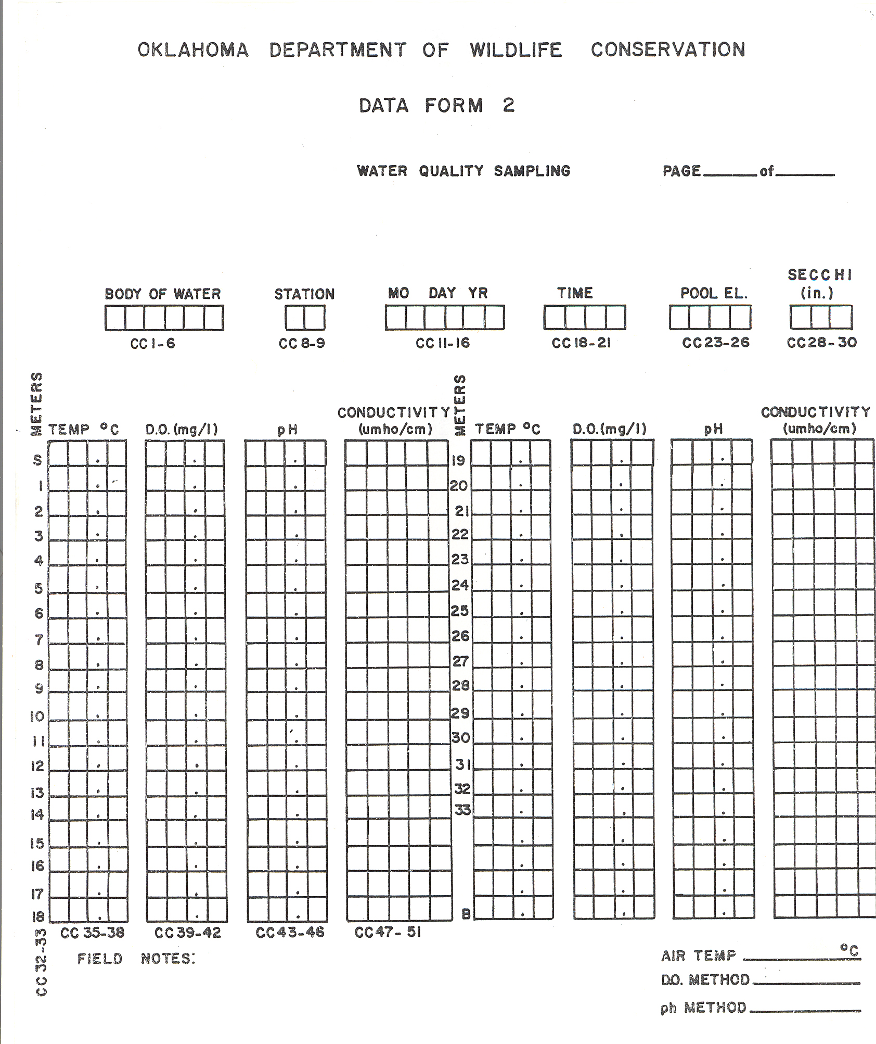

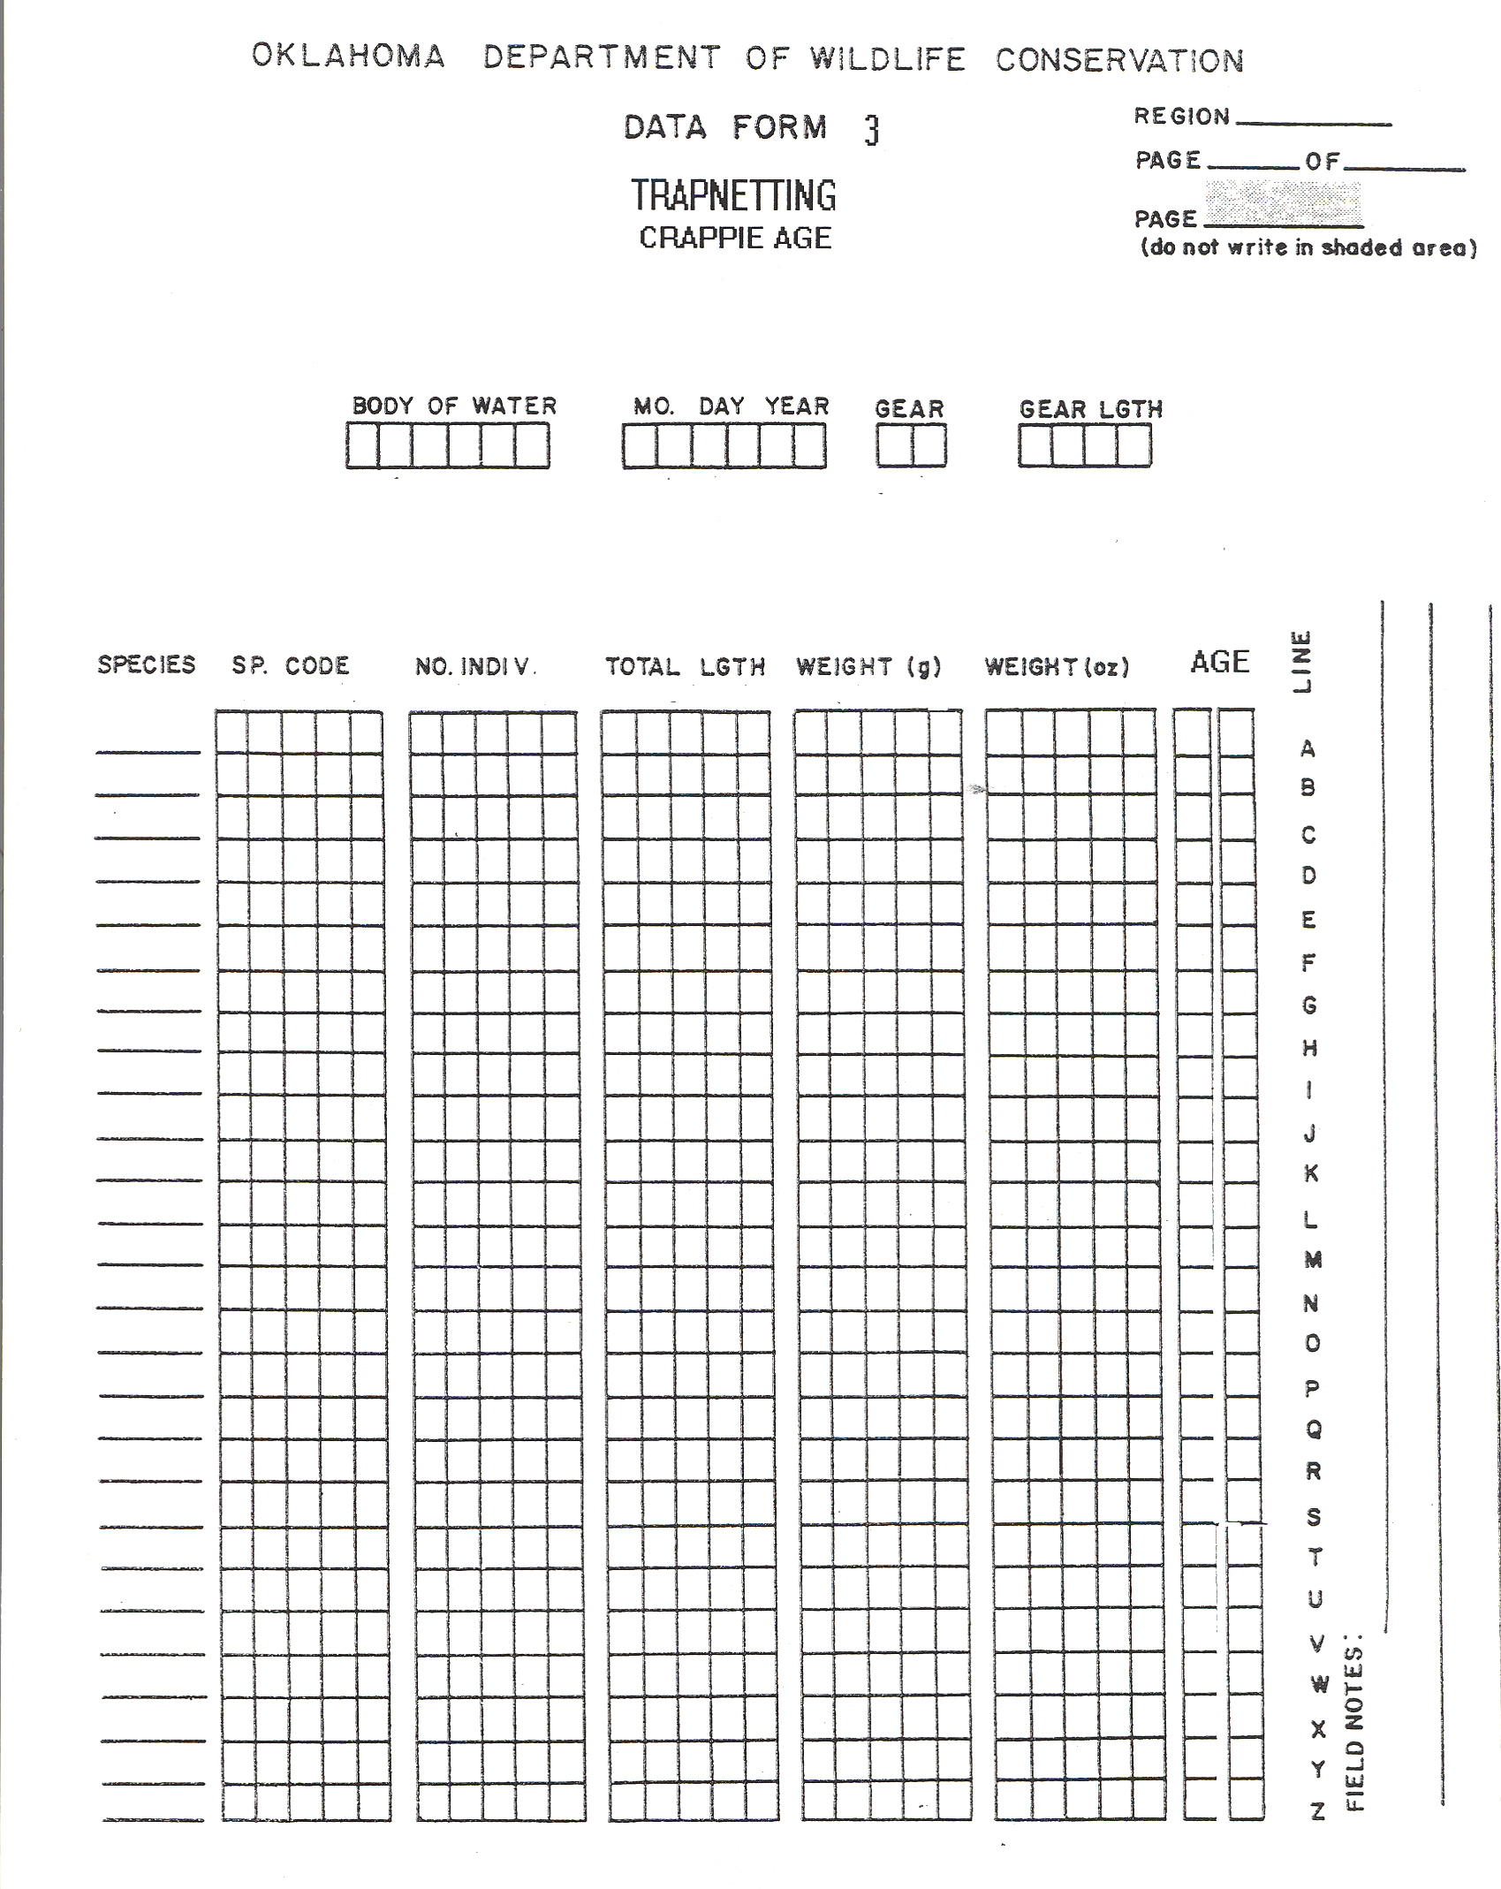

Annual Report Format

TABLE OF CONTENTS